WOMEN IN SCIENCE 2022
12 FEBRUARY 2022.
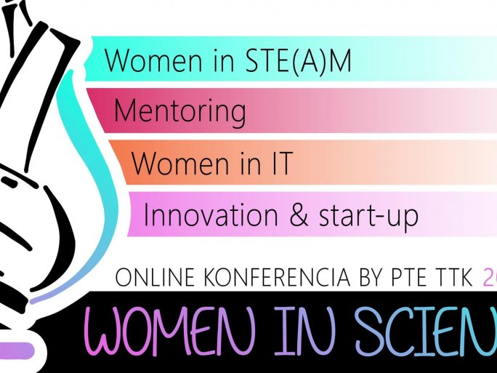
Following two highly successful conferences (previous events can be accessed on this website), the international online conference organized by the Women in Science - Women in Challenging Careers team has become part of the UP Centenary 2022 event series. The event was held in style on 11 February in the online space, as it was World Women in Science Day. This year's invited speakers not only provided insights into the Hungarian context but also revealed why the topic is still so interesting in the twenties of the 21st century.
Professor Andrea Pető (CEU, Department of Gender Studies) spoke about the gender implications of so-called polypore political systems, where women are underrepresented in politics, political discourse is characterized by anti-intellectualism, human rights and economics are appropriated by power, and scientific results are questioned, according to the researcher from the now Vienna-based organization.

"There will never be an ideal time to have children.
If the relationship calls for it and the mother becomes pregnant, you should be happy, accept and embrace the situation," said Zsuzsanna Márka dr., a researcher, and physicist at Columbia University. It was heartbreaking to hear her talk about how she was so confident with her first child that she would not get sick much - but life proved her wrong. She also talked about how her husband took his share of the child-rearing load and how they had to be flexible with their lives to accommodate their children's ages and needs and their own careers.
In comparison to the US, Brigitta Majoros, a data sourcing, and analyst (HERE Technologies) shared some of her experiences in the IT sector. She gave examples of things you wouldn't think would happen, such as the lack of a women's restroom or specific questions about starting a family during the selection process.
However, certain segments of the labor market concerned are forward-looking. "There are 50 IT companies in Pécs alone, and hundreds of freelancers," noted Ferenc Brachmann, CEO of IT Hub Pécs. The IT sector is growing, its very nature has blurred national borders: you can work anywhere in the world and earn an international salary. "It is human capital that needs to be addressed," Ferenc Brachmann stressed, adding:
"The growth opportunity for the IT sector is to attract women, and this is also a business interest. "
"If we fail to attract women to certain industries, we will not have enough workers," said Tamás Novák dr., a specialist diplomat at the Consulate General of Hungary in New York, who said that this is one of the reasons why the White House has set up a Gender Policy Council to make recommendations to the US government on how to improve the situation of women in the labor market.
Tamás Novák dr. said that engineering is the most gender-biased sector, while the proportion of women in science is slightly higher.
The online event was recorded and can be watched on this YouTube channel.

