WINTER ICE CREAM, TURBO CHEWING GUM, AND A SPUN SKIRT
16 MARCH 2022.
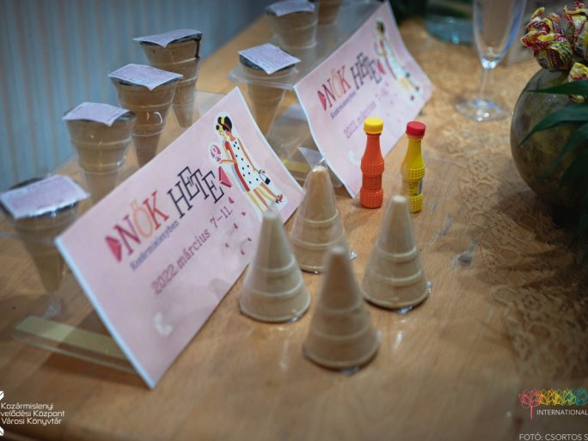
The joint event of the University of Pécs and Women's Week in Kozármisleny on 11 March, entitled "The place of such a girl is in a disco - from the Kádár era to the present day", was a true retro event.
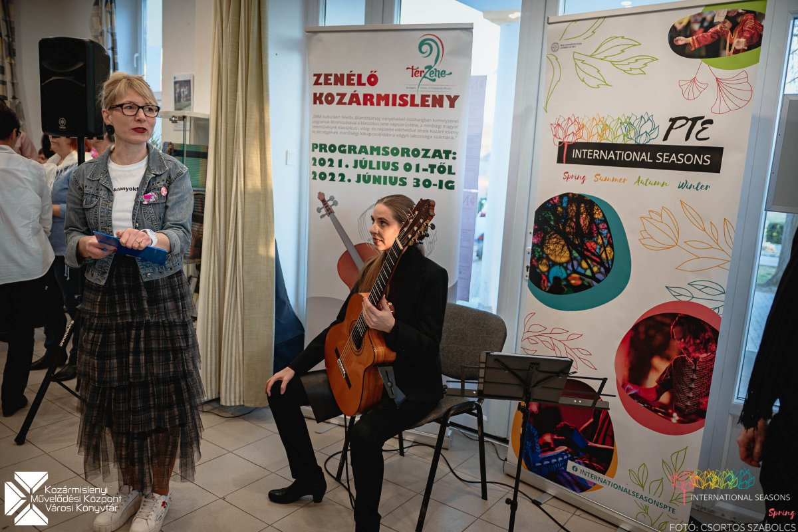
The all-night event started with an exhibition opening by Károly Bíró dr. Mayor, Attila Miseta dr., Rector of the UP, and István Tarrósy dr., International Director of the UP. The event was organized as part of the International Seasons program, in conjunction with the Women's Week in Kosármisleny. The university's aim is to support the rapid integration of the 4,000 foreign students from nearly 110 countries and the almost 500 Ukrainian refugee students who have recently joined the UP family. As part of the program, there will also be events in Africa, Asia, and Latin America, among others, which will provide an insight into the cultural values, customs, and traditions of our students.
"The place of such a girl is in a disco - from the Kádár era to the present day" was designed to evoke the retro world of the 1970s and 1980s in all its elements. The same was true of the sweets on display, where visitors could choose for themselves
from turbo gum, snow cones, Kojak lollipops, butterscotch, and other retro sweets.
The exhibition was called @Kádár_Insta or #Fashionable # every day in the happiest barracks and was curated by Petra Egri.
This was followed by the CultureSalon Exclusive - a roundtable discussion on femininity with four amazingly talented, successful, and exemplary women.

While the Kádár era was characterized by an economy of scarcity, today the problem is that everything is "there". The choice is too wide and it is difficult to choose the real value.

After the discussion, Tímea Benkő Lánczos, stylist of PONT Pécs, opened the retro fashion show, where the patterns, colors, and styles of the '70s and '80s were back in the pieces on the catwalk.
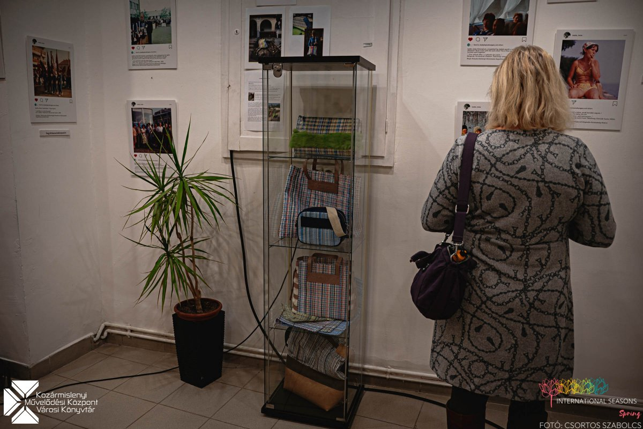
The evening closed with a call to "Dance, come on, dance some more!" and a retro disco with disco balls, a huge dance floor, and a great atmosphere, bringing the International Seasons and Women's Week program to a fitting closure.

