WHAT KIND OF LEADER WOULD I BE?
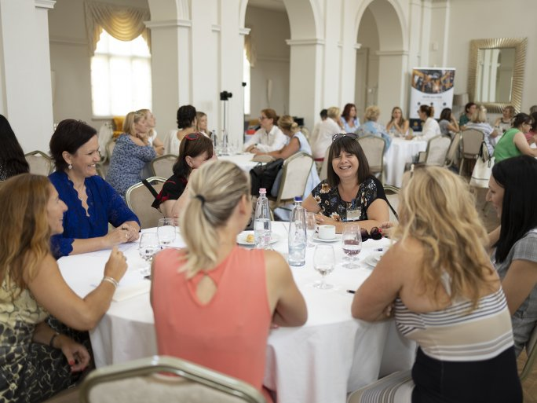
"What kind of leader would I be?" is the title of an informal discussion organized by the Institute of Transdisciplinary Research of the Medical School of the UP on 22 April. At the event organized by the Women's Leadership Club of the Hungarian Business Leaders' Association, ITR, the Career Office of the UP, and the Doctoral Students' Government of the UP, you can talk to experienced women who have worked in the competitive sector for over a decade, or who are in the process of fulfilling their academic careers and holding senior positions about the beauty and challenges of leadership.
During the discussion, you will be invited to join the panel to find answers to questions such as
- what makes a good leader?
- what skills are needed to become a leader?
- is someone fit for the responsibilities of leadership?
- how much of a role model is needed?
- whether there is a work-life balance and, if so, how to achieve it.
The moderator of the discussion will be Andrea Dintsér, head of the Women's Leadership Club of the Hungarian Business Leaders' Association, and founder and head of YourStory.hu, an integrated marketing and communication agency.

More details: itdweb.hu/milyen-vezeto-lennek/

