WE BRING AFRICA CLOSER!
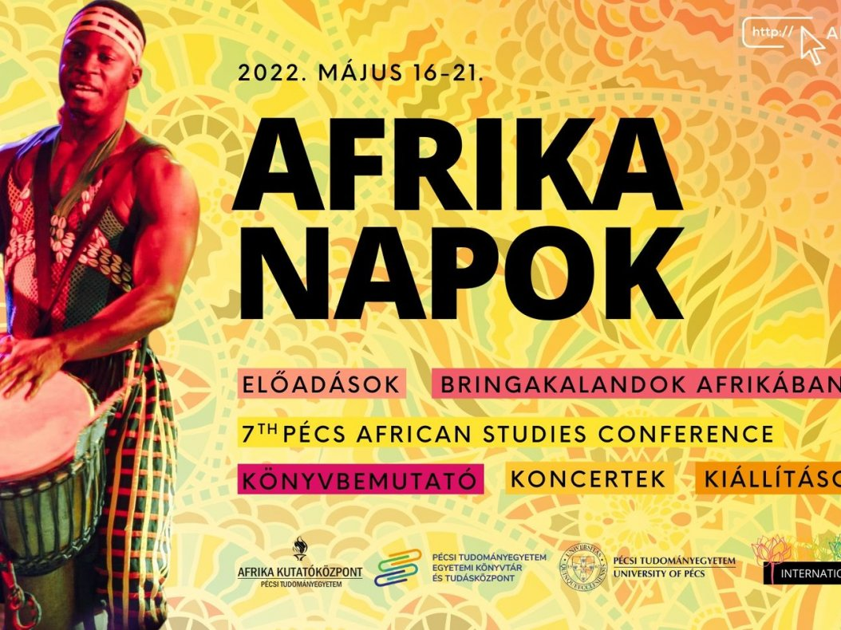
The International Seasons series of events at the University of Pécs ends the academic year with Africa Days every year. And this year will be no different, with the richest program ever offered, for 6 days, between 16-21 May 2022, the lectures, exhibitions, concerts, and the 7th Pécs African Studies Conference, held in the Knowledge Center on 19-20 May 2022, will be waiting for those interested in Africa.
About the programs:
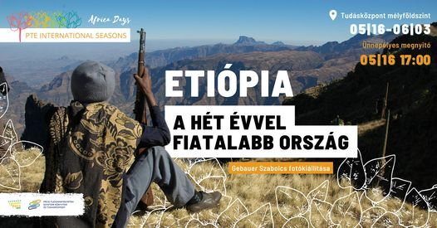
Monday 16 May, 17:00 - Knowledge Center - Ground floor (2/A. Universitas street, Pécs 7622)
Ethiopia - A country seven years younger - Szabolcs Gebauer, journalist, will present a selection of his experience from his two-week trip to the Ethiopian highlands
The exhibition is open until 3 June.
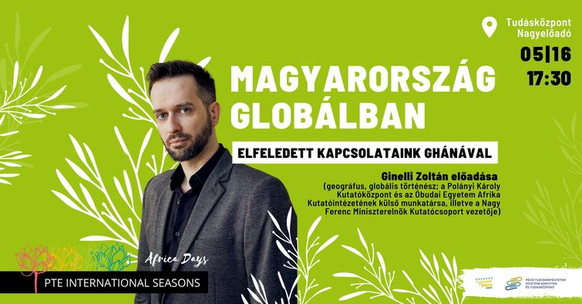
16 May (Monday) 17:30 - Knowledge Center Grand Lecture Hall (2/A. Universitas street, Pécs 7622)
Hungary in the global: our forgotten relations in Ghana - Lecture by Zoltán Ginelli, geographer, global historian
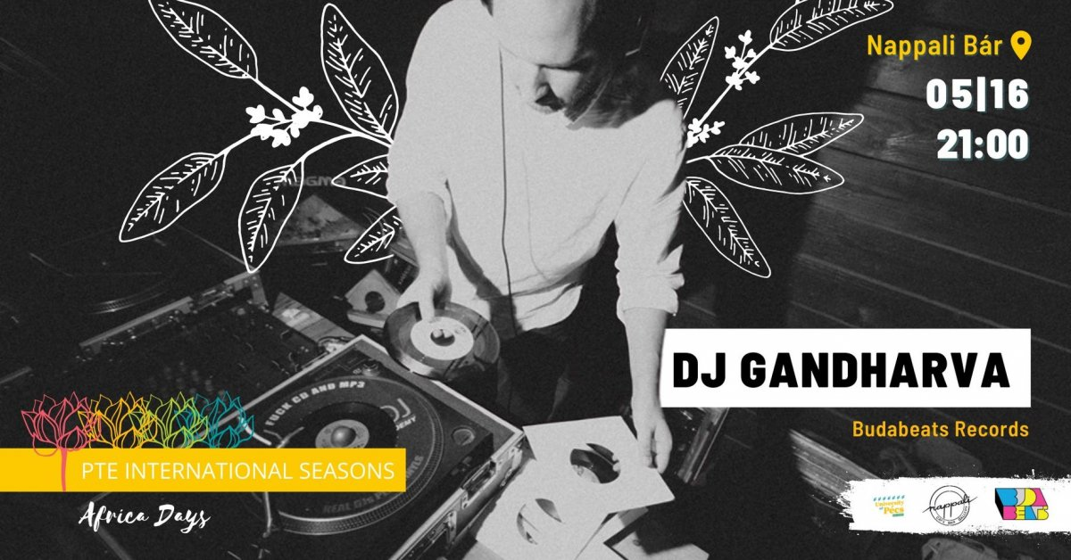
16 May (Monday) 21:00 - DJ Gandharva - Nappali Coffee Shop
(23-25 Király street, Pécs 7623)
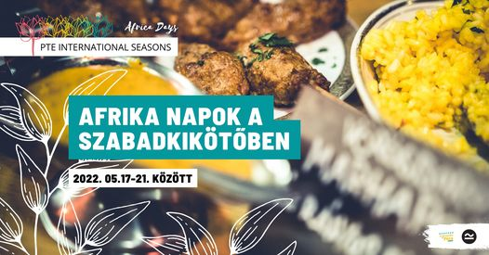
17-21 May - Africa Days at the Free Port (64 Király street, Pécs 7626)
The Free Port kitchen will join you on an exciting journey. This week, small-scale, seasonal ingredients will be used to cook North African, Ethiopian, and South African dishes. Citrus, tagine, Piri - Piri, Ethiopian common bowl, and South African potjiekos are on the menu!
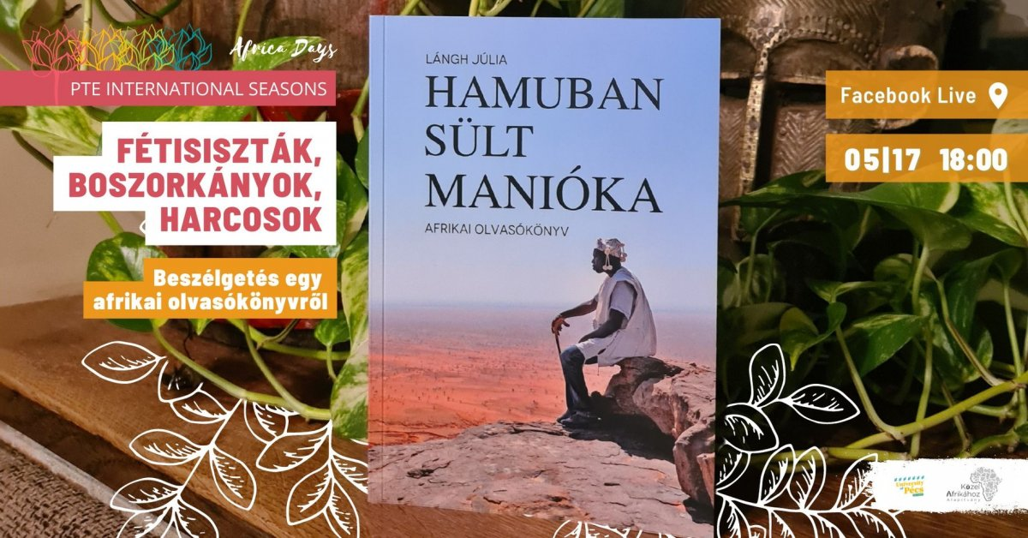
17 May (Tuesday) 18:00 - Facebook live on InternationalSeasons.
Fetishists, witches, warriors - a discussion about an African reading book - we talk to Júlia Lángh, Milán Füst Prize-winning author about the African reading book and the themes it raises. Júlia's interlocutor: Robert Balogh, journalist, poet and literary critic.
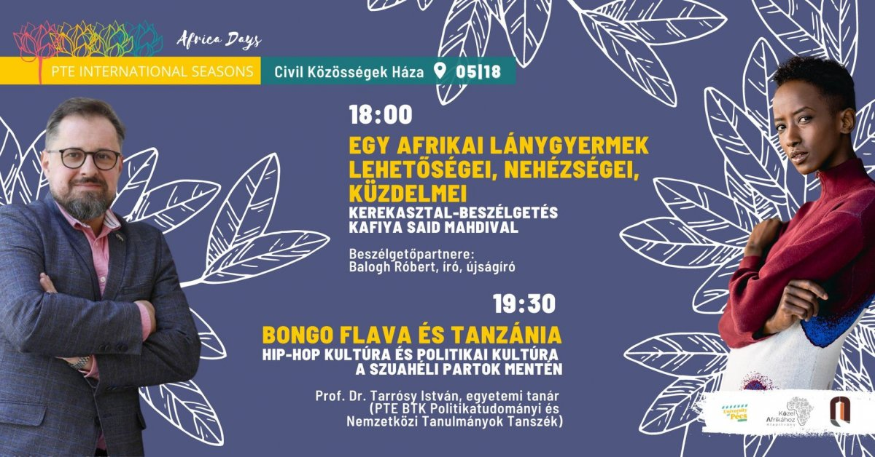
18 May (Wednesday) 18:00 - House of Civil Communities (17 St. Stephen’s square, Pécs 7624)
Opportunities, difficulties, and struggles of an African girl-child - Conversation with Kafiya, Somali model, and Andrea Morris, director of the Near Africa Foundation

18 May (Wednesday) 19:30 - House of Civil Communities (17 St. Stephen’s square, Pécs 7624)
Bongo Flava and Tanzania. Hip-hop culture and political culture along the Swahili coast - musical lecture by István Tarrósy prof. dr., Professor (Department of Political Science and International Studies, Faculty of Humanities and Social Sciences)
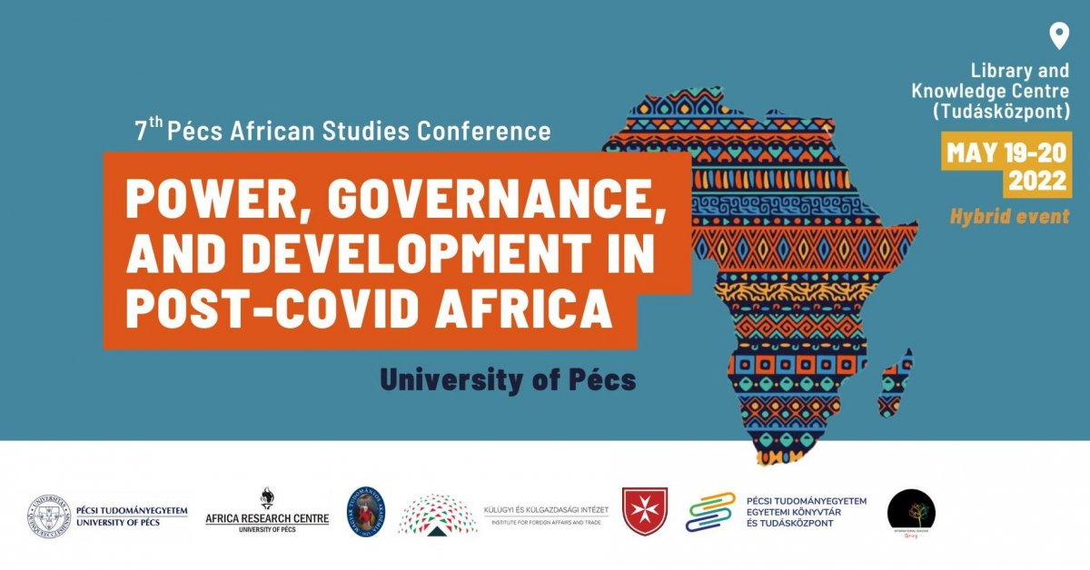
19-20 May - 7th African Studies Conference of Pécs - Knowledge Center (2/A Universitas street, Pécs 7622)
The conference will be held in English! - Participation is free, but registration is required.
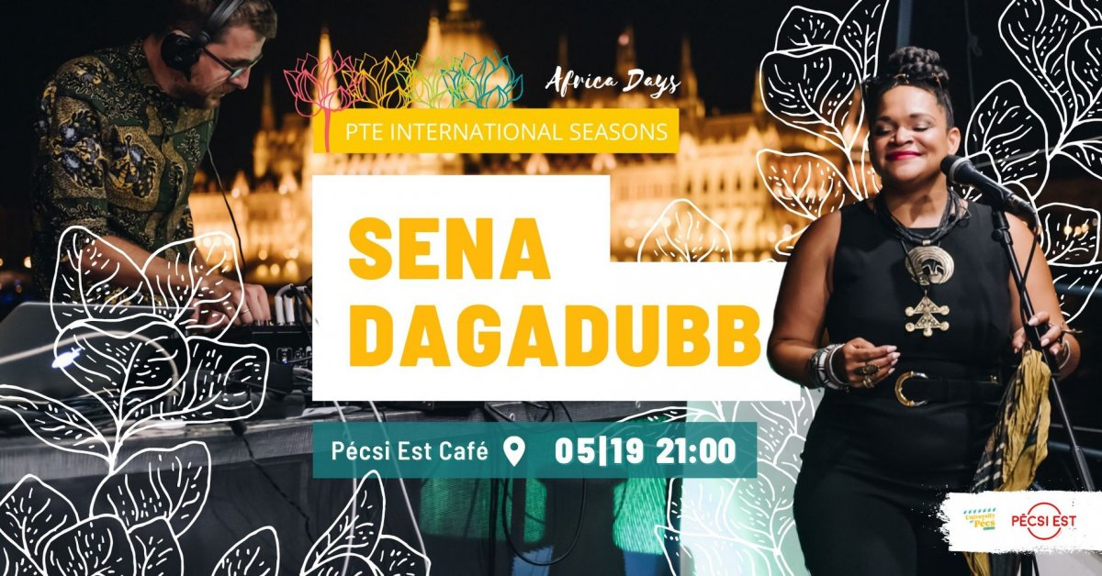
19 May (Thursday) 21:00 - Est Café of Pécs (46 Rákóczi street, Pécs 7621)
Sena Dagadubb concert
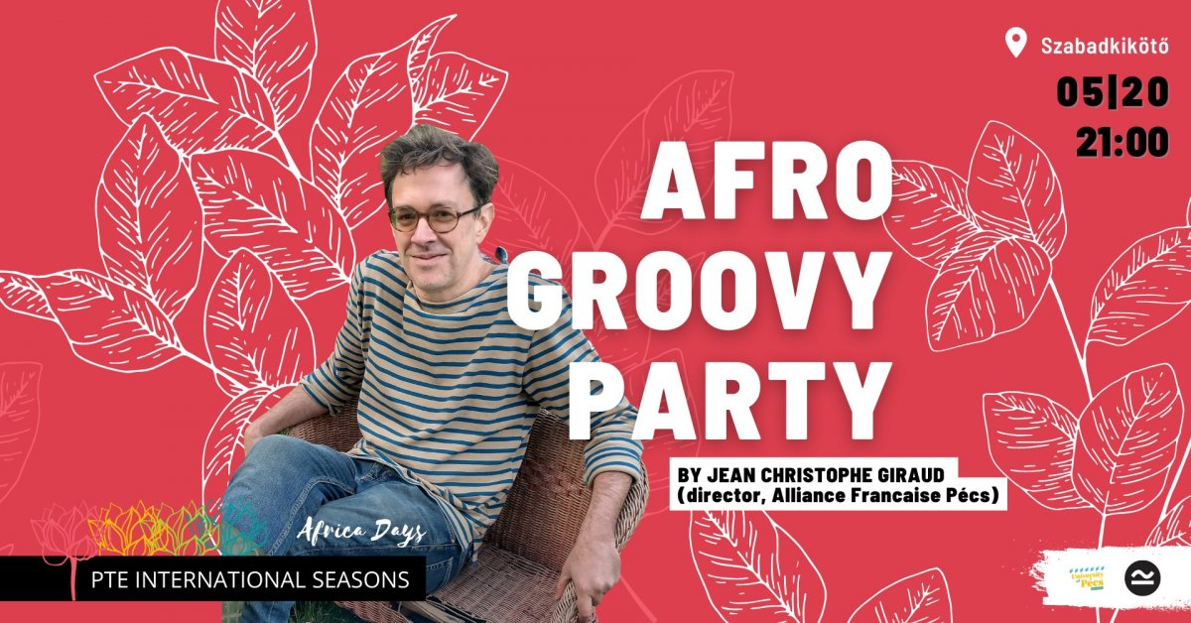
20 May (Friday) 21:00 – Free Port (64 Király street, Pécs 7626)
Afro Groovy Party by DJ Jean Christophe Giraud
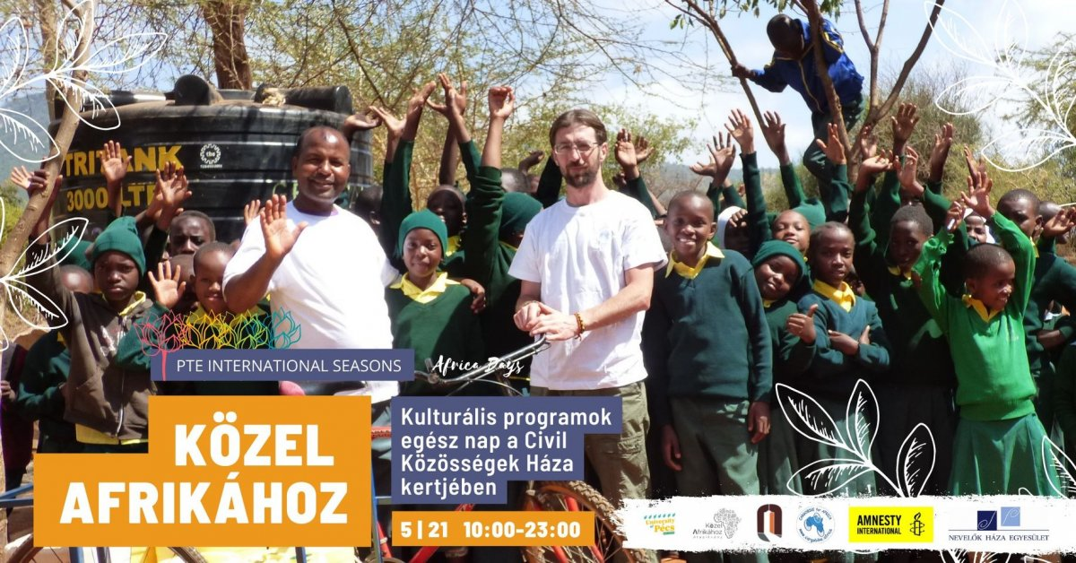
21 May (Saturday) from 10 am - House of Civil Communities (17 St. Stephen’s square, Pécs 7624)
Close to Africa - Cultural programs all day at the House of Civil Communities
We are looking forward to welcoming our guests with several cultural programs at the House of Civil Communities. Children's programs, African dance demonstrations, drumming, an African pub quiz, and a DJ Director will close the evening.
The programs are open to all and free of charge.
Click on the link to see the full weekly program.

