USED OIL COLLECTORS AT SEVERAL INSTITUTIONS OF THE UP
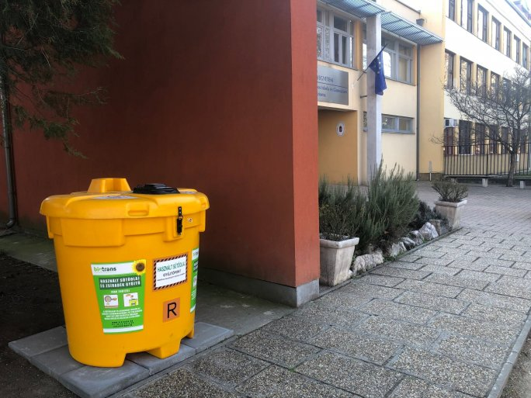
Several institutions of the University of Pécs, such as the UP Affiliated Babits Mihály High School and the kindergarten of the University of Pécs, have also installed a used cooking oil collector, which aims to protect the environment and recycle the used oil.
The UP Affiliated Babits Mihály High School is an eco-school and is therefore committed to sustainability and global responsibility education. In this spirit, a new element of its environmental education program has recently been added: a collection point for used cooking oil has been set up near the entrance of the high school, with the support of the NotADrop! A similar container was placed at the western entrance of the kindergarten, also run by the UP.
Used oil is highly polluting, carcinogenic, and toxic, and once out of the household it causes huge damage, so it needs to be collected and treated in the same way as plastic or batteries.
Used household oil and grease can be placed in the collection container in its original packaging, PET bottles, or jars without dropping it. The company will clean and recycle the oil after disposal. The Babits High School will receive a token amount of money for the oil collected, which will be used for further sustainability-related programs.
The Babits High School asks everyone not to pour the oil collected at home down the drain, but to join their initiative and reduce the impact on the environment. The collector can be used not only by students and their families but also by all citizens of Pécs who are committed to nature.
The initiative also fits in with the Green University Program of the UP, which plans to open more collection points.

