TM CAMP MENTORS AND MENTEES DAY
20 FEBRUARY 20, 2022.
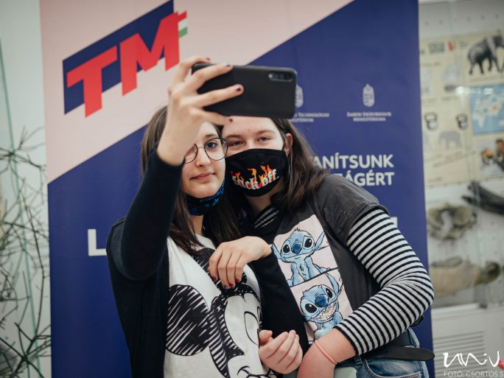
TWITTERFACEBOOKGOOGLE+
40 students from 3 rural schools met with 10 university students who have taken on the role of mentors at the Pécs Zoo on 17 February, as part of the Teach for Hungary program.
The children arrived in three buses from Kétújfalu, Baksa, and Magyarmecske.
The forty students met ten university mentors from different faculties of the UP at the Pécs Zoo.
They took part in a zoo educational program, which included playful activities combined with a guided tour. Some of them were visiting a zoo for the first time, others had already been there on a school trip. The students loved the seal and the leopard, but the animals they got to pet were the biggest hit.
What was more important than the shared experience, though, was that the mentors and the would-be mentors got to know each other.
At the University of Pécs, after seven successful semesters, the Teach for Hungary program will continue in the spring semester of the 2021/22 academic year, to give primary school children from disadvantaged small towns the same chance to continue their studies or find a job as their urban counterparts. The experience so far is that the number of children who are mentored is much higher than those who are not.
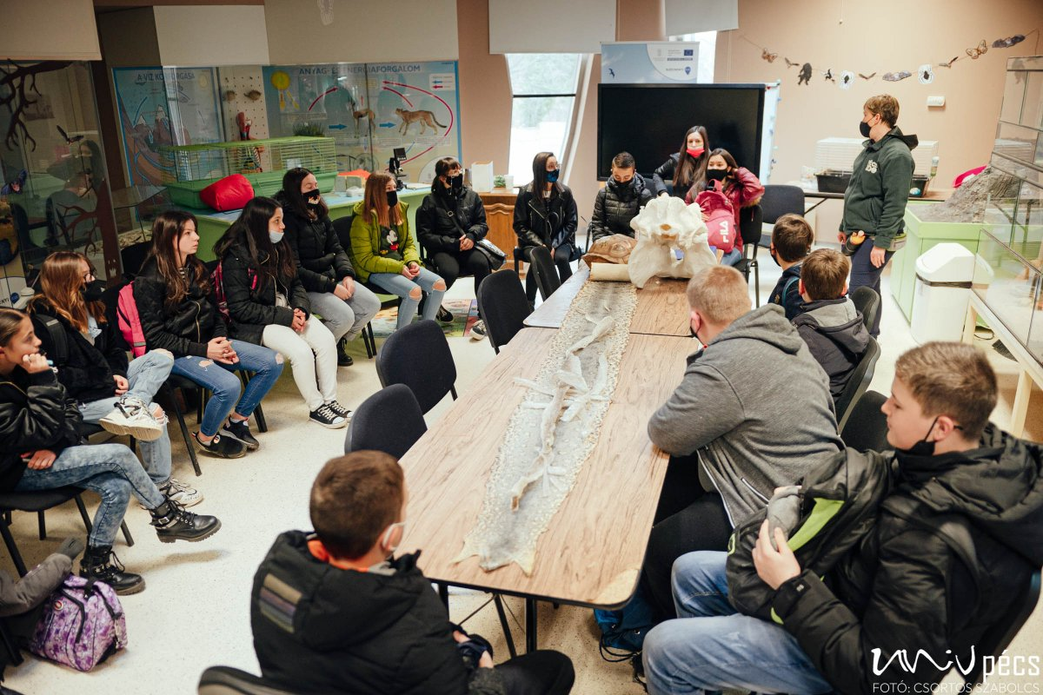
The mentors help pupils in grades 6-7-8 from disadvantaged small towns in Baranya County to complete their primary education, to prepare for further education, to continue their studies without interruption until they reach the secondary level and be able to make the most of their studies - be it vocational training, school-leaving exams, further education, sports, arts and ultimately finding a job in the labor market. The program also provides an opportunity for university mentors to show students the excitement and opportunities of the world beyond the settlement - zoos, museums, high schools, and businesses.

