THE XXV JUBILEE SPRING WIND CONFERENCE WAS A SUCCESS
This year, the Spring Wind Conference, an international scientific event organized by the National Association of Doctoral Students, took place for the twenty-fifth time. The University of Pécs won the right to organize the jubilee event this year, so the multidisciplinary conference was hosted by the city of Pécs (Kodály Center, South Transdanubian Regional Library and Knowledge Centre) from 6-8 May.
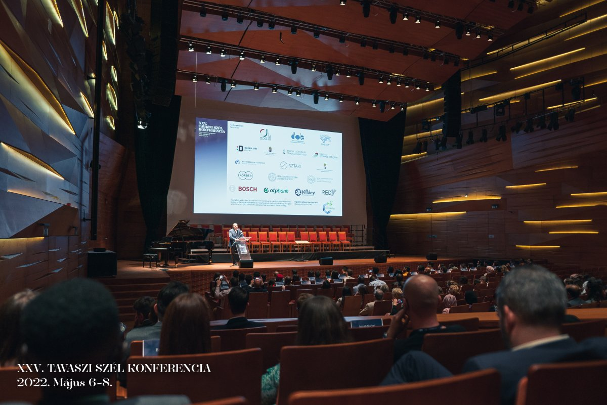
The event provided an opportunity for Hungarian doctoral students and young researchers from Hungary and beyond to present their research results and establish personal and professional collaborations. Doctoral students from all over the country and from a wide range of disciplines came to present their scientific results in the form of lectures and posters in English and Hungarian.
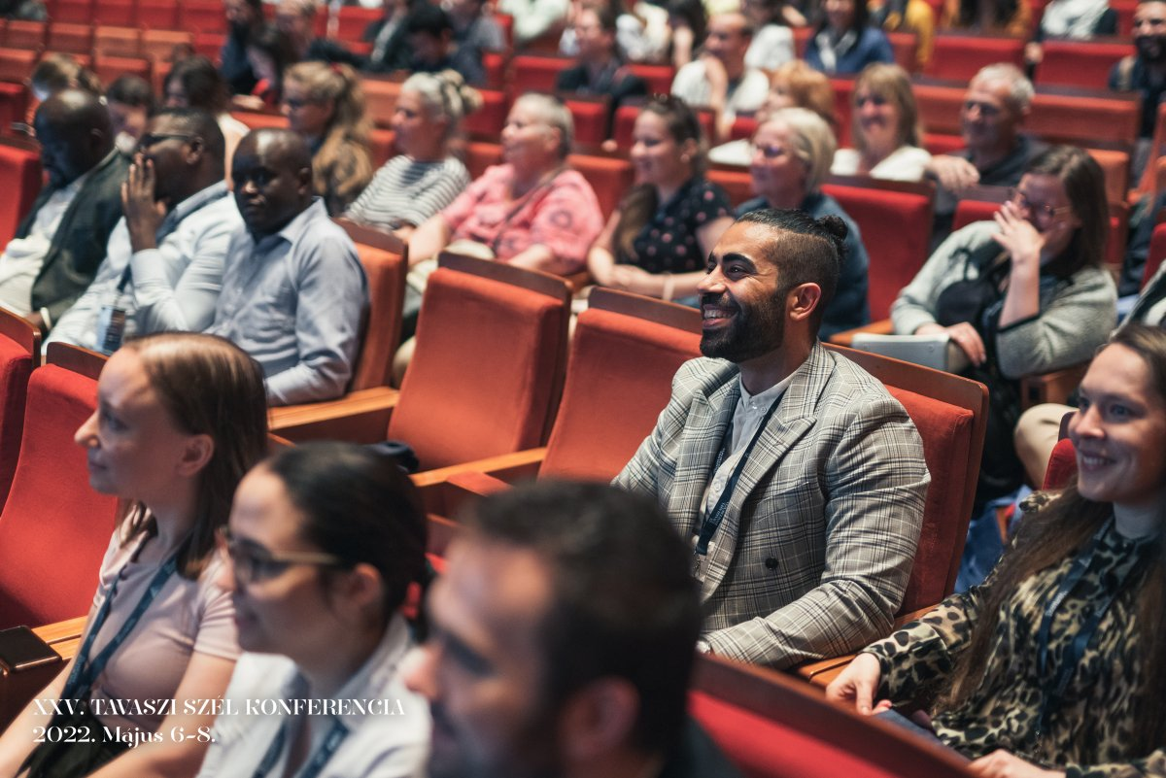
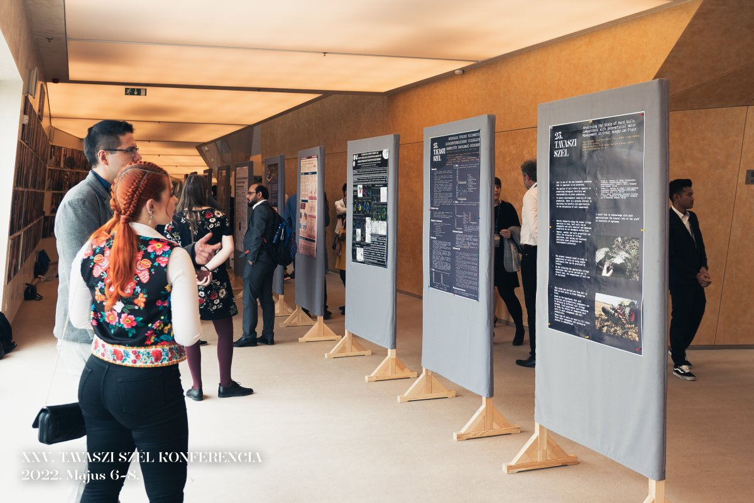
In addition to the 21 scientific sessions, the organizers also provided 2 poster sessions, which were open to the public as part of a poster walk. More than 500 speakers attended the event. Prizes and special awards were given to the best speakers (National Laboratory for Artificial Intelligence Special Award, Hunexpert Special Award).

