THE UP WINS NEARLY 1.5 BILLION HUF OF EXCELLENCE FUNDING TO STUDY BRAIN FUNCTION AND DISEASES
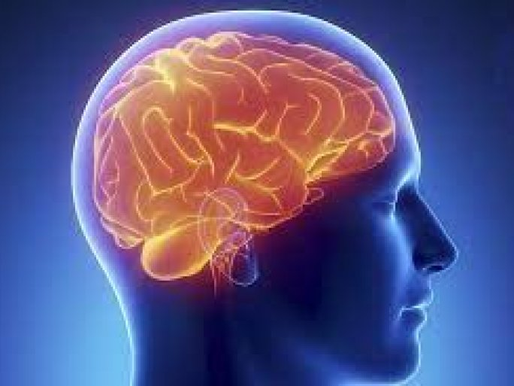
The National Research, Development, and Innovation Office's Thematic Excellence Program 2021 Health sub-program has awarded a further 4 years of funding for the project "Investigation of brain function and diseases using a multidisciplinary approach", worth a total of HUF 1.493 billion.
Dr. Tamás Dóczi, Professor at the University of Pécs, head of the project, summarized the project's professional content:
"Understanding how the brain works and how to cure its diseases is one of the greatest scientific challenges of our time. To understand in detail the processes underlying brain lesions, close cooperation between discovery and clinical research is needed.
Under the 2020 Thematic Excellence Program, more than 100 researchers have implemented a multidisciplinary network of 25 research teams. Researchers from the Neurosciences Center of the UP, the Medical School, the Faculty of Sciences and the Faculty of Pharmacy, the Clinical Center, and the Szentágothai János Research Center are involved in the research.

