THE UP WINS 1.2 BILLION HUF EXCELLENCE GRANT FOR PHARMACEUTICAL RESEARCH
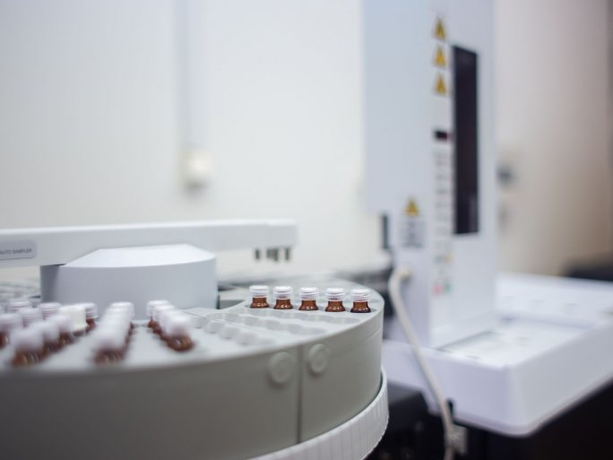
The National Research, Development and Innovation Office's Thematic Excellence Program 2021 Health sub-program "Identification of new drug targets, biological, physical and chemical testing and development of synthetic and natural drug candidates for mitochondrial diseases" has been awarded a further 4 years of funding for a total of HUF 1.2 billion.
More than 100 researchers from the Medical School, the Faculty of Sciences, and the Faculty of Pharmacy, as well as from the Clinical Center, who have already achieved excellent results, will participate in the 2021 Thematic Excellence Program. The research ranges from the synthesis and characterization of new compounds using a variety of highly efficient, yet environmentally friendly tools, to full-scale chemical and physical characterization, biochemical research, and clinical trials.

