THE UP WELCOMES STUDENT REFUGEES FROM UKRAINE
05 MARCH 2022.
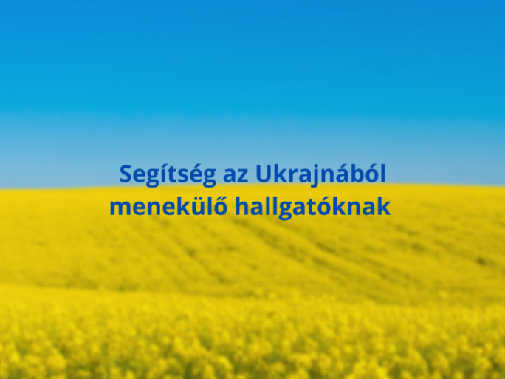
The University of Pécs has opened a special application platform for students who are fleeing the war in Ukraine but wish to continue their studies. At the University of Pécs, refugees can continue their studies in more than 100 English-language and hundreds of Hungarian-language courses.
Students are automatically exempt from paying the application fee and the University is currently working on further student-friendly financial details.
The Hungarian language courses are available here: https://pte.hu/hu/felveteli/kepzes
The English version is available here: https://international.pte.hu/study-programs
In addition to filling in the application form, applicants should upload as many documents as possible on their previous studies into the application system in order to enable the University to make an appropriate decision on admission. The University of Pécs is committed to providing each student with the most appropriate, personalized support for their studies.
The University of Pécs stands for peace and helps those in need.

