THE UP RECEIVES NEARLY 1.4 BILLION HUF FOR RESEARCH AND DEVELOPMENT IN INDUSTRY AND DIGITALIZATION
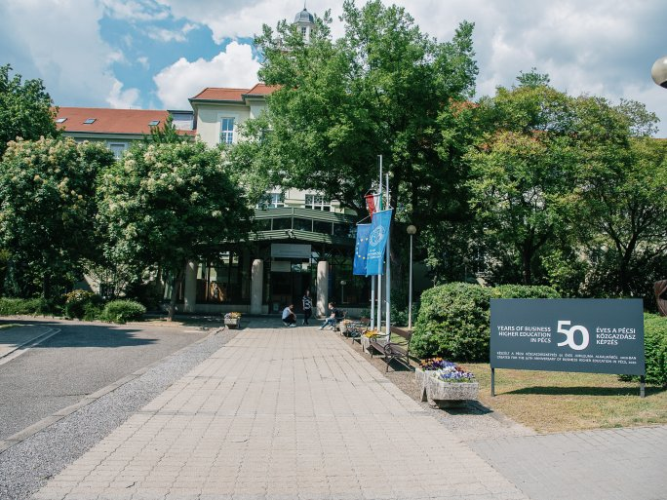
In the framework of the National Research, Development and Innovation Office's subprogram THEMATIC EXCELLENCE PROGRAM 2021 NATIONAL RESEARCH "Increasing the role of domestic companies in the reindustrialization of the nation", project was awarded a further 4 years of funding, worth a total of HUF 1.386 billion.
The sub-program aims to build on the professional excellence of higher education institutions to carry out thematic research and development programs that promote the development of responses to civilization challenges and trigger further development and innovation processes within the institution, while the results of the research also have a significant social and economic impact.
Rapid socio-economic changes in recent years have created a dividing line between the previous phase and the new program of excellence. The new research agenda should address the impact of the pandemic, digitalization/artificial intelligence, and changes in the natural environment. An important research question that will arise in the course of professional work is whether the pandemic has increased or decreased the role of industrial activity in achieving economic growth. The competitiveness and competencies of SMEs are a key issue in terms of economic competitiveness, managerial decision-making, and the use of strategic assets. Identifying both successful and less successful firms capable of growth is an essential component of growing the Hungarian economy and laying the foundations for re-industrialization.
The results of the project should include a new economic evaluation and thinking system to enable professionals to assess the impact of investment and development on economic growth, not only in the short-term but also in the long-term, with a view to sustainability. Long-term thinking will be strengthened by providing training for young academics in the world's most prestigious universities and by using the teaching materials developed there in Hungarian higher education.

