THE UP PREPARES THE ENERGY RENOVATION OF 17 BUILDINGS
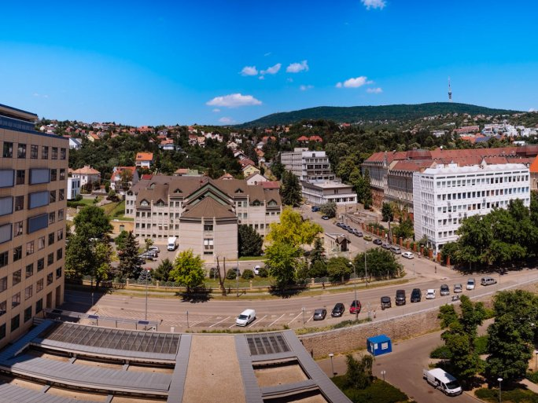

The University of Pécs has won support to prepare for the energy renovation of 17 buildings. The project will be implemented by the institution with EU funding, with a total of HUF 421.49 million in non-reimbursable grants. As part of the project, the aim is to prepare energy efficiency plans for the buildings concerned and, based on these plans, to launch and finalize the public procurement procedures for the construction works.
The University of Pécs has been paying increasing attention to becoming a "Green University" in recent years. The efforts in this regard are already reflected in objective indicators, with the UP ranking 42nd in the Green Metric World University Ranking 2021, and the best out of the 11 Hungarian universities participating in the initiative. One of the pillars of the sustainable, green concept is the sensible management of environmental resources, thus energy efficiency.
However, looking at the scores in the Green Metric ranking category for infrastructure conditions referred to above, it can be seen that the UP has room for improvement and that it is justified to improve the energy efficiency of buildings in poorer conditions.
Project identification: KEHOP-5.2.15-21-2021-00003

