THE UP LAUNCHES A PHOTO CAMPAIGN ON EARTH DAY
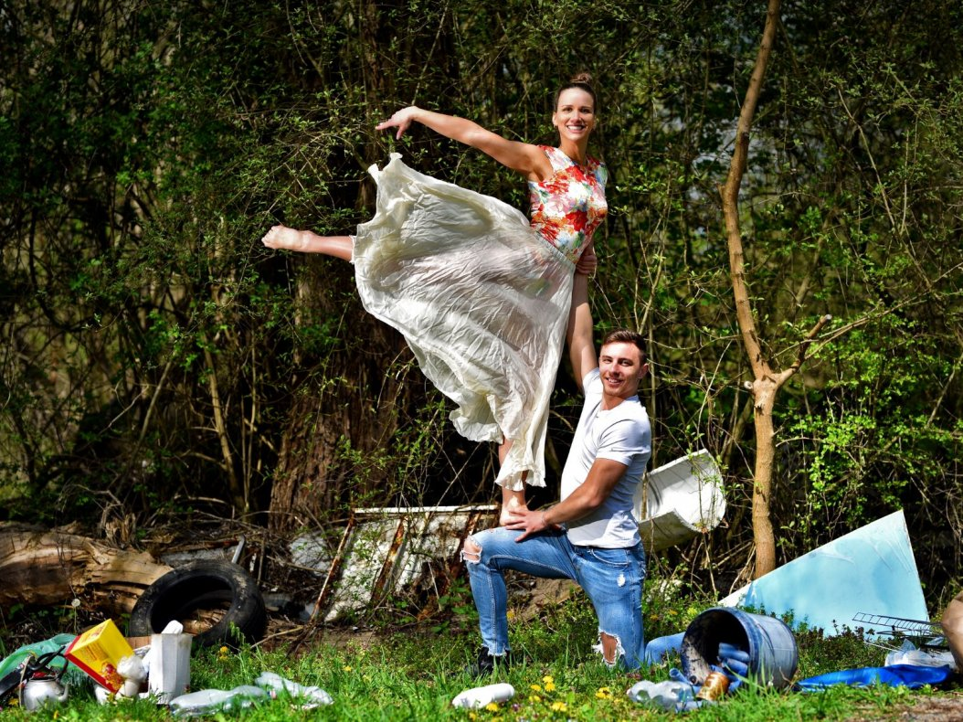
One of the aims of the environmental photo campaign launched by the Green University of the UP and the Dance Ensemble of the UP on 22 April, Earth Day, is to draw attention to the fact that we often don't even notice the destruction and pollution that surrounds us. We smile and turn our heads in the other direction instead of doing something about it.
That's why the campaign's visuals show spectacular, eye-catching movements against a backdrop of often startling realities. So there is a juxtaposition between a graceful climb onto a pair of spike shoes with discarded rubbish, a cool somersault with discarded tires in the natural environment, a light lift in plastic-filled water, or a leap in the smog.
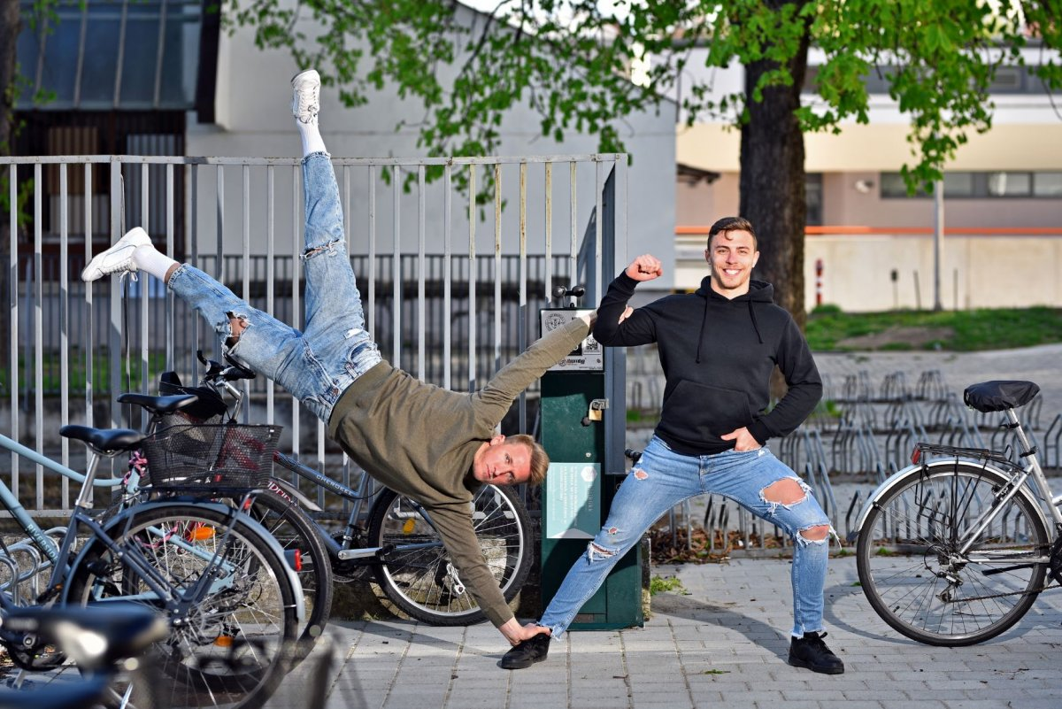
At the same time, the UP's environmental ambitions are also shown through dance and acrobatics in another part of the campaign, showing that it is possible to do things differently. The University of Pécs is trying to do something for a cleaner, more liveable future with several initiatives, many of which are shown in the photos, all of which are of course accompanied by green dance steps.
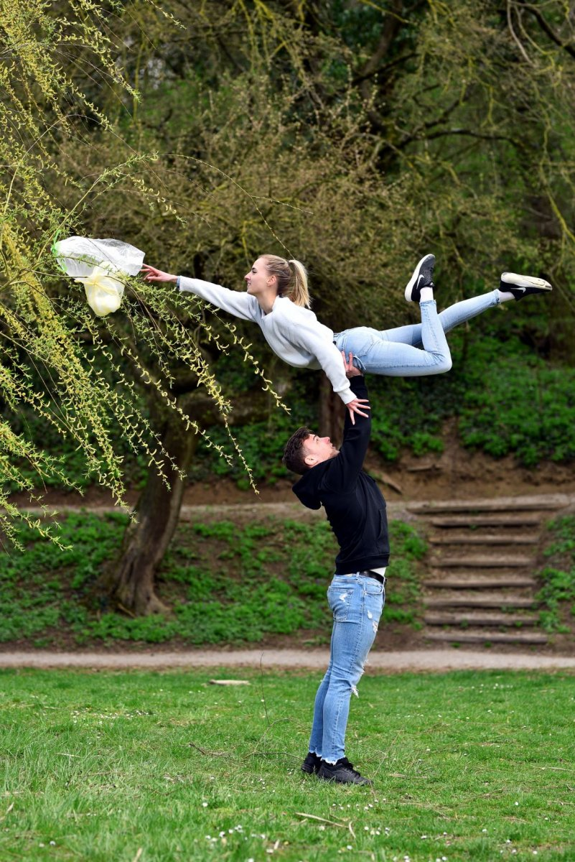
You can follow the photos on the Facebook and Instagram pages of the Dance Ensemble of the University of Pécs in the coming weeks.
