THE UP DRESSED PÉCS IN GREEN
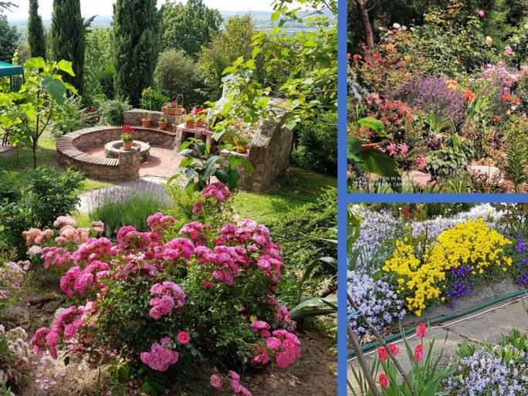
This year's "Dress green or dress your environment green" game, organized by the University of Pécs in connection with Earth Day, was a great success.
Nearly 200 citizens of Pécs and the university shared a part of their colorful flower and herb gardens or dressed in green, raising awareness of the importance of protecting our planet. A compilation of the entries and the winners' names are available on the Green University website.
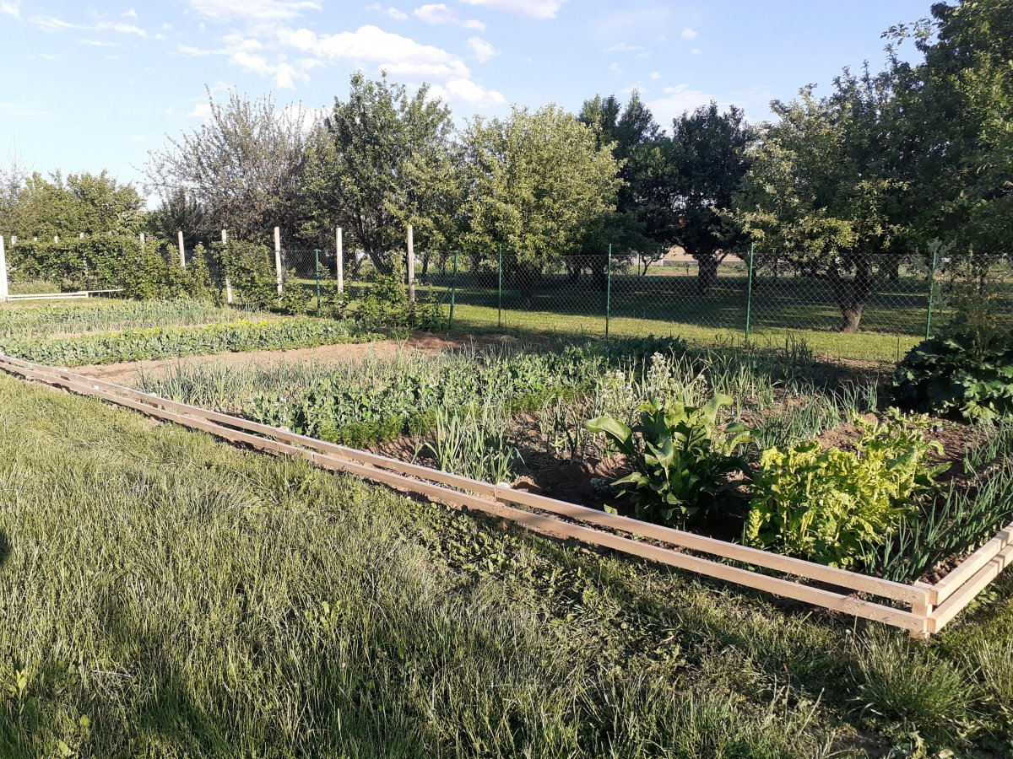
It's not every day you see such a beautiful vegetable garden...
As we all know, the mission of Hungary's first university is to encourage best practices and innovation in sustainability and sustainable management through the Green University program and to shape and strengthen ecological awareness through science and education.

