THE UP CAN LAUNCH A MASTER'S DEGREE IN SUSTAINABLE DEVELOPMENT
11 FEBRUARY 2022.
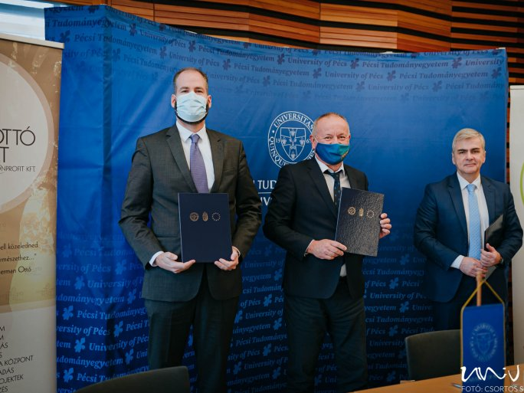
The University of Pécs and the Herman Ottó Institute Nonprofit Ltd. have signed a cooperation agreement on environmental protection, nature conservation, rural development, and related education, research and development, and innovation activities. The agreement was signed on Friday morning in the Senate Council Chamber of Hungary's first university by Attila Miseta, Rector of the UP, Péter Bozzay, Managing Director of the Institute, and Gábor Szécsi, Dean of the Faculty of Cultural Sciences, Education, and Regional Development of the UP.
As it is known, the Rural Development Research Center was established at the end of 2018 at the Faculty of Cultural Sciences, Education, and Regional Development of the UP, in cooperation with the region's municipalities, county governments, NGOs, and chambers of commerce, contributes to the realization of the region's rural development goals by conducting research, advisory and training programs, presenting good practices and establishing professional communities of farmers. In line with the strategic priorities of the Faculty of Cultural Sciences, Education, and Regional Development of the UP, the Center is primarily concerned with the professional coordination of local and regional rural development projects. The activities of the Rural Development Research Center are closely linked to the objectives of the Herman Ottó Institute, which, as a non-profit Limited Liability Company wholly owned by the Ministry of Agriculture, focuses on environmental protection, nature conservation, and rural development.
In addition to traditional educational programs, an important area of cooperation is the development of higher education that is able to respond flexibly to market needs, support the development of research, development, and innovation activities, and the development of short-term training programs and professional training courses to meet the training needs of the areas covered by the Company.
It was announced at the event that the Faculty of Cultural Sciences, Education, and Regional Development of the UP, with the professional support of the Herman Ottó Institute, plans to launch a Master's program in sustainable development. In addition, the Faculty will set up a working group within the framework of the Center for Rural Development, whose primary task will be to coordinate professional and scientific cooperation, provide training and research services, and coordinate joint tenders. For the joint work, the faculty will also provide the institute with an office at its headquarters in Szekszárd.

