THE UP AND THE PÉCS-BARANYA CHAMBER OF COMMERCE AND INDUSTRY COOPERATE
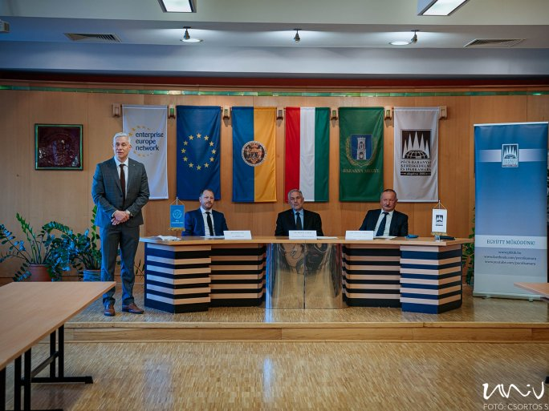
The joint goal of the University of Pécs and the Pécs-Baranya Chamber of Commerce and Industry is to promote economic and social development in the region, in the settlements of Baranya County, in the city of Pécs, through the competitiveness of the economy, to increase capital and wage incomes, to improve the quality of life, and to create a prosperous local economy and society. To this end, the parties signed a cooperation agreement at the headquarters of the Chamber of Commerce and Industry on 2 March. The signing ceremony was followed by an informal discussion with other guests.
The economic and social development of Baranya County and the region in the 21st century is based on a knowledge-intensive economy. Local industry must be part of the technological wave of the fourth industrial revolution, and it is in the common interest of the institutions of the region to promote the development of competitive services and productive activities based on digital knowledge and new technologies in Pécs, Baranya County, and South Transdanubia.
Following the strategic agreement, the latest cooperation agreement with concrete terms and deadlines was signed by Attila Miseta dr., Rector of the University of Pécs, Tamás Síkfői dr., President of the Pécs-Baranya Chamber of Commerce and Industry, and István Decsi, Chancellor of Pécs. "The university is an obvious source of supply for industrial companies in the region. If these companies are committed to helping students to study with scholarship opportunities, the region's retention capacity will also increase," said Attila Miseta dr., Rector of the University, and added:
"It is a good opportunity for the industry to apply jointly with the university.
Szabolcs Rabb, Secretary General of the Chamber of Commerce and Industry, presented the history of the cooperation between the UP and the Pécs-Baranya Chamber of Commerce and Industry, which aims at the development of the region. The President of the Chamber, Tamás Síkfői dr., said that "if we want to build a knowledge economy, we have already missed out on the two big waves of industrialization, now we can get on a third wave, which is linked to digitalization."
This will require the joint development of the university knowledge base and the training and recruitment of an increasing number of skilled workers, technologists, engineers, and researchers to meet the technological challenges of the industrial revolution. A new type of cooperation between the local and regional economy and the university must be developed, which will allow a significant increase in added value in the Baranya economy, contribute to a sharp rise in exports and encourage the integration of county businesses into international value chains. The region's current low investment attractiveness needs to be increased.
"The changes that go hand in hand with the change of ownership will not only mean an additional surplus in terms of quantity but also in terms of quality," said Chancellor István Decsi. To develop priority areas such as engineering, information technology, economics, or medical and health sciences
"We also need partners, local firms, companies, family businesses, large international companies here, and the framework that the Chamber provides for us."

