THE TEAM OF THE FACULTY OF ENGINEERING AND INFORMATION TECHNOLOGY OF THE UP WINS THE HUMAN-CENTERED INTERIOR DESIGN AWARD AT SOLAR DECATHLON

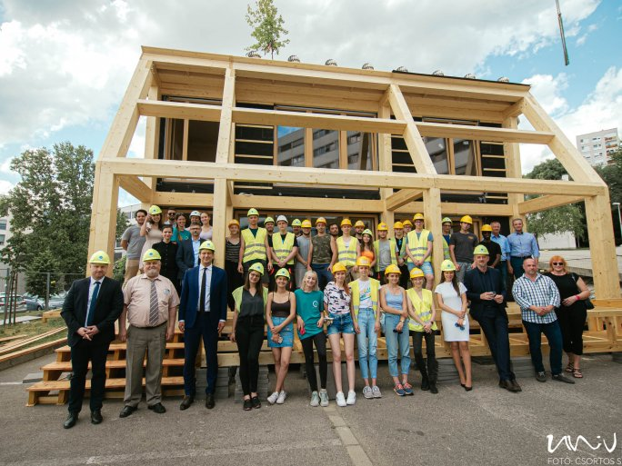
A multi-functional residential building with unique solutions, the MAGYAR FÉSZEK+ eco-positive home, has won the 2022 Wuppertal Solar Decathlon Human Centred Interior Design Award. The Lungs of the city Team of the Faculty of Engineering and Information Technology of the University of Pécs was the only Hungarian participant in the international construction innovation competition for students this year, building its model home demonstrating sustainability in just over 14 days, based on renewable energy sources. The project of the Pécs-based team goes beyond the architectural aspect, with the extra-energy house, which has zero or negative emissions, placing a strong emphasis on ecological sustainability and environmentally positive architecture, as well as social responsibility.

The team of the Faculty of Engineering and Information Technology of the University of Pécs was the winner of the "Human-centred Interior Design" category of the innovation competition, which brought together 16 international universities, and was awarded 1st prize by the jury. "The Human-Centred Interior Design Award is not only about interior design, but rather about how a building, the environment, people, and nature can coexist in a humane way and with high quality while being represented in the interior in a way that represents sustainability and environmental cooperation. In the case of MAGYAR FÉSZEK+, the building is intertwined with the external nature, the materials used in the building, the unique furniture, and the artworks provide a whole, derived from man and nature, which, in terms of their renewability, represent an artistic value that is forward-looking in the long term", says Tamás Kondor dr., Head of the Lungs of the city Team and Vice Dean of the Faculty of Engineering and Information Technology of the University of Pécs. The building was designed on a real plot of land for young graduates who will stay in Pécs and set up their own businesses in addition to living in the building. The inner core of the house can be transformed into a green environment, supporting economic livelihoods and providing an eco-friendly healthy living space for the residents.

The excellent performance in the competition was made possible by the cooperation of a number of businesses, institutions, and construction service providers. The participation was also significantly supported by the Ministry of Innovation and Technology.

Univ TV's video on the topic can be seen here:

https://www.youtube.com/watch?time_continue=1&v=J6OF0YRvNoI&feature=emb_logo

