THE FACULTY OF ENGINEERING AND INFORMATION TECHNOLOGY DEVELOPS A UNIQUE OCCUPATIONAL HEALTH AND SAFETY APPLICATION

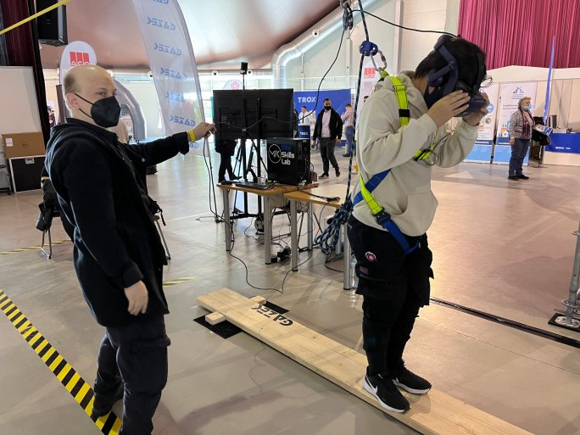
You have to walk on a wooden plank on the scaffolding of a skyscraper, and if you make a mistake, you won't fall off, because the fall protection device will keep you from falling. It's a half-virtual, half-real sensation, because you actually put on the safety equipment before starting the game simulation, so you can feel it in the physical world, and it will hold you up even if you fall off the scaffolding or step on the plank. The BIM Skills Lab Research Group at the Faculty of Engineering and Information Technology of the University of Pécs has developed a unique, innovative development related to the digital construction industry with the fall protection company, GAZEK. Virtual reality is linked to a physical device, so that the experience of a simulation with occupational safety risks is transformed into a real feeling. The development allows for the safe and realistic presentation of accident-prone situations.

