THE FACULTY OF BUSINESS AND ECONOMICS OF THE UP IS AMONG THE BESTS AS A RESEARCH SITE AS WELL
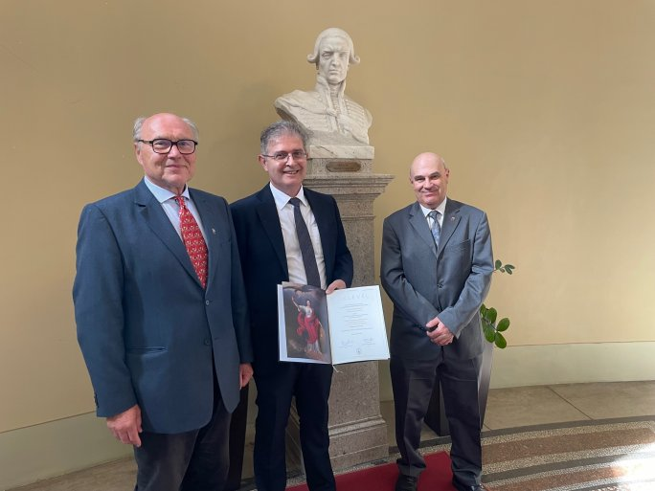
On 4 May, Zoltán Schepp dr., Dean of the Faculty of Business and Economics of the University of Pécs (UP), received another prestigious award on behalf of the University. The award, the title of HAS Outstanding Research Center, presented at the Academy's headquarters, recognizes the Faculty's competitive scientific activities in the international arena.
"This is a particularly great achievement in the light of the fact that we are the only university faculty, and not an independent research institute, to have earned this recognition in the field of economics.
I think that since our main task is education, it also means that we have excellence in general. This is also confirmed by the fact that in 2019 we received EFMD program accreditation for our teaching activities and institutional operational background, and now our other profile, research, has received equally prestigious recognition," said Zoltán Schepp, Dean of the Faculty.
The main criterion for the award of the Outstanding Research Center status was the value and impact of publications on international scientific platforms, as well as the innovation index of the research. During the judging process, the work of the last 5 years was highlighted.

