THE CHARM OF ANTIQUITY

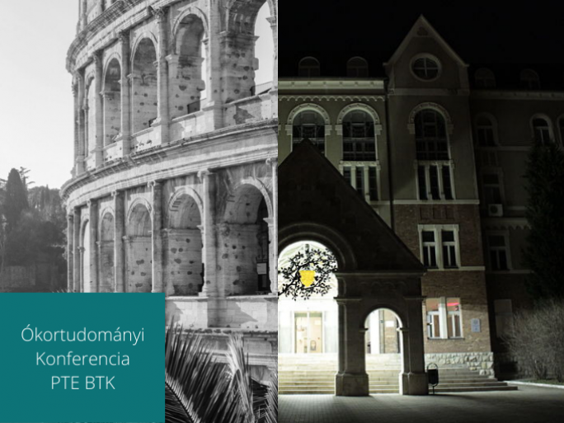

A recorder conference will start on 19 May at the Faculty of Humanities and Social Sciences of the University of Pécs: 170 speakers are expected to participate in 18 scientific sessions at the national event of the Society of Ancient Studies and Hungarian universities dealing with ancient studies. The event is organized by the Departments of Classical Philology, Ancient History, and Archaeology of the Faculty of Humanities and Social Sciences of the University of Pécs. A special feature of the event will be the second performance of two contemporary cantatas based on fragments of Euripides' tragedy Antiope, and the presentation of a reconstructed ancient musical instrument, the aulos. The concert and the conference as a whole are free and open to the public.

Conference
Antiquity attracts young people and proves that this science is not about dusty, uninteresting things, but also about us, the people of today.

Sessions range from Egyptology through Assyrology to Hebraism and Ancient India.

Concert and the sound of a forgotten ancient instrument
"Euripides was a modern composer in his time, and there are fascinating fragments of his work in this field.

Methodology and the future
Two round-table discussions will take place on the final day of the event.
The event in Pécs will also include a special moment to celebrate the winners of the Pannon Competition Games. The University of Pécs launched the competition in the autumn of 2015, and from 2021 it is organized together with the Palladion Workshop, specifically for secondary school students. Hundreds of students competed in the last competition and will be welcomed at the conference in Pécs.

