TEN SILVER LINDEN TREES AROUND THE KNOWLEDGE CENTER
To mark Earth Day, ten silver linden trees were planted on the west side of the Knowledge Center, lining the access road, by the staff of the University Library on 26 April. The Green Library work group was the organizer and initiator of the event, with BIOKOM Ltd. as a collaborating partner.
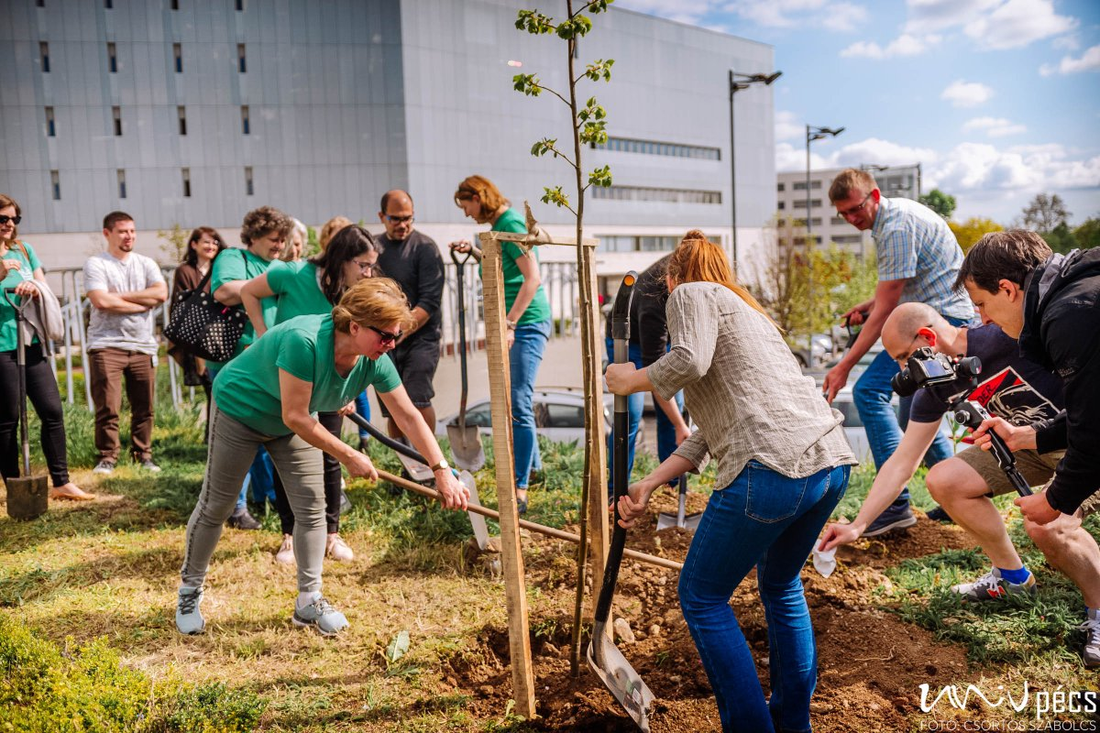
If you plan for one year, plant a seed, if for ten years, plant a tree, if for a hundred years, educate - Gábor Szeberényi, quoting a Chinese proverb, wittily linked the tree planting to the Centenary celebrations of the UP. The director stressed that although Earth Day is the occasion for the event, the library has also done and will continue to do activities to promote climate change and the greening of the environment.

The 10 trees also represent the library units of the 10 faculties of the University of Pécs, a reference to the scientific diversity of the library.
The time will come when the trees surrounding the building will bear butter-yellow flowers and the scent of linden will sweeten the reading experience - let us remember this day.

