SURVEYING THE CONDITION OF CENTURIES-OLD BUILDINGS WITHOUT DEMOLITION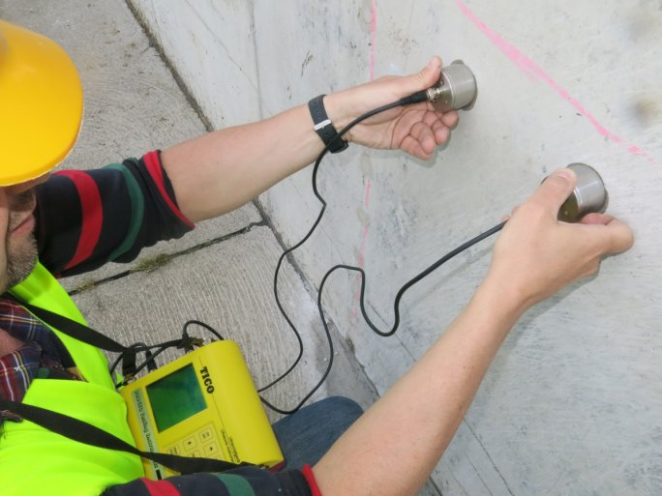
Irreversible damage can be caused to architectural monuments and historic buildings if they are treated or renovated without proper expertise. In our country, in addition to the tens of thousands of listed buildings, there are countless historic buildings, and in order to plan their professional maintenance, renovation, or conversion to a new function, 21st-century diagnostic procedures are needed that allow the structures to be studied with as little intervention as possible. By recognizing this, two years ago the Faculty of Engineering and Information Technology of the University of Pécs launched a new training course, which adds two unique areas to the knowledge of future professionals in an incomparable manner: special modules on Building Information Modelling (BIM) for design and on non-destructive testing. The first cohort from Pécs will graduate in July 2022.
In the field of heritage conservation, there is an increasing need for professionally trained, innovative, and project-oriented professionals with a holistic approach, and thorough knowledge of the structure and materials of historic buildings, the theory and practice of diagnostic methods used for their mapping.

Uniquely in Hungary, the training includes two distinctive Pécs specialties that strengthen the technical side of the training: the non-destructive testing and diagnostics of historic structures, and the BIM (Building Information Modelling) module from the design side. "Our students have the opportunity to gain insight into the work of these two university research groups and the application possibilities of the latest technical background", says Krisztián Kovács-Andor dr., associate professor in charge of the training.

