RESEARCHERS FROM THE PHYSICS INSTITUTE OF THE UP HAVE PLAYED A KEY ROLE IN A MAJOR EUROPEAN UNION PROPOSAL
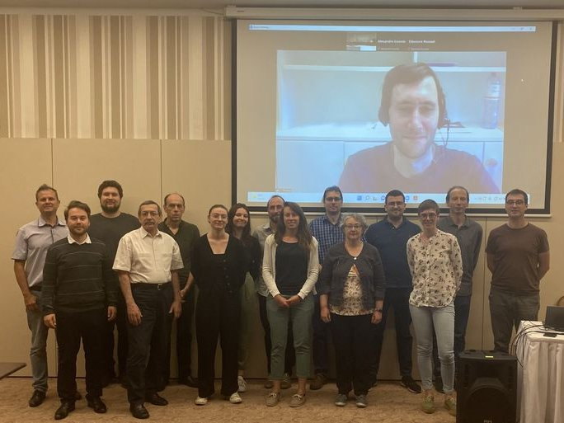
The inaugural of the 3.6 million euro TWAC Horizon Europe project, which is being implemented with the significant participation of researchers from the Institute of Physics of the University of Pécs, took place in Pécs between 18 and 20 May.
The project aims to build a terahertz electron accelerator in order to make the accelerated electrons suitable for later use in cancer therapy (flash therapy).

