"REFORM EVENT CATERING"
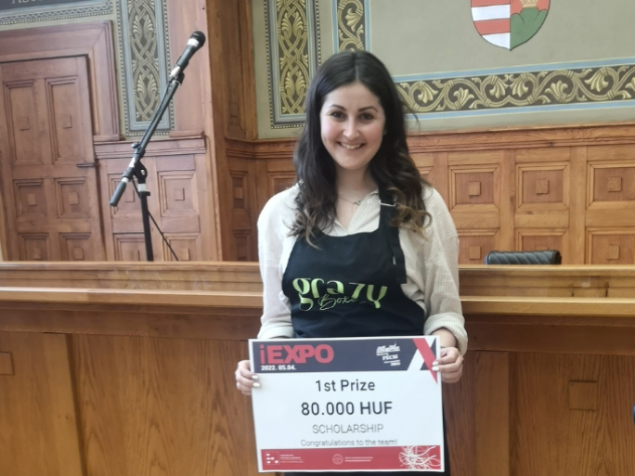
Grazy Boxes was the winner of this year's iEXPO reverse career fair project competition at the Faculty of Business and Economics of the UP. I interviewed the inventor of the idea, Elizabeth Gellén, after the event organized by the Center for Applied Learning (CAL) of the Faculty of Business and Economics of the UP on 4 May in the József Halasy-Nagy Aula.
Who hasn't been drooling and watching the grazy box-making video on Instagram or tweets?! There's so much variety and so much spectacle in these food boxes - and especially the tables - that it's a joy to watch them being put together. What's more, this trend in catering is based on the fact that local producers are usually sought out, and care is taken to ensure that the snacks offered for consumption are seasonal produce in the spirit of sustainability, and there are even some that provide only recycled versions of the packaging and the utensils used for snacking.
Elizabeth Gellén dropped the ball on the gastronomic experience, the visual experience, eco-sustainability, and boosting the local economy in Pécs in a course on economics. "On a picnic day, when I packed everything up and took a picture, lots of people gave me feedback on what a great package I had put together."
By the end of the course, she had to come up with a project, but the young girl didn't wait until the end of the semester: halfway through the semester, on March 12 to be precise, she turned her idea into a business.
"I'm trying to reform event catering! I want to stop having dry scones at conferences, for example.
I think there's a creative way to present everything Hungarian and local on a table."
- says Elizabeth Gellén
Collaborating with local producers is the basis of her business: 'I like to approach people whose products are not very well known, even though they taste great and everyone is amazed by the quality. I want to support these producers, but I also want to keep the price at an affordable level. The main thing is to give the experience to remember an event by. In my experience, a good starting point for that is good food.
The winner of the iEXPO will graduate from the Faculty of Business and Economics of the UP in December this year, and with first place in the project competition, she also won a HUF 80 000 scholarship.
