POLLACK EXPO - TRADITION, INNOVATION, COOPERATION
24 FEBRUARY 2022.
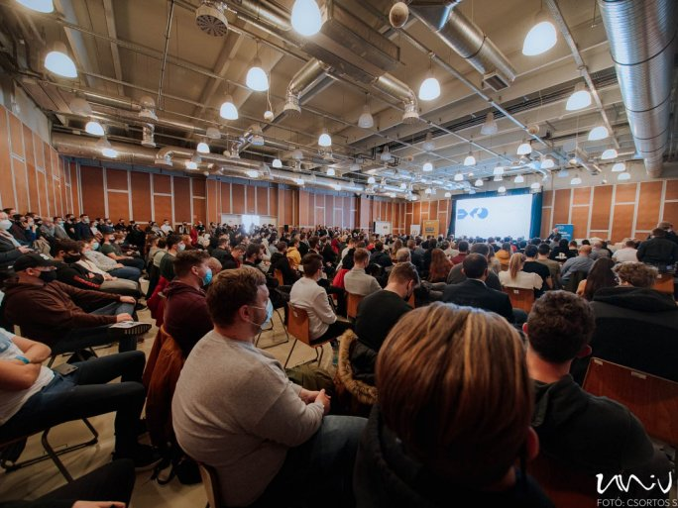
After two years, the Faculty of Engineering and Information Technology of the University of Pécs once again hosted the Pollack Expo, the largest technical and construction exhibition and conference in the region, live on 24-25 February at the Expo Center. The event, described as a meeting place for the university, industry, and the engineering community, was organized for the 15th time this year. Around 100 presentations and more than 110 exhibitors presented new products and solutions in the fields of architecture, building services, mechanical engineering, information technology, and environmental and electrical engineering.

"The University of Pécs has an extremely important task to cooperate much more effectively with industry and service providers in the future, which will require a major change of approach on our part. In this context, the Faculty of Engineering and Information Technology has a special role to play."
- Rector Attila Miseta dr. stressed in his opening speech. "It is a particular pleasure to have the opportunity to strengthen our cooperation with both domestic economic players and the leaders of a global company," said Chancellor István Decsi, who pointed out that the expo also provides an opportunity for the corporate sector to get to know the future workforce:
"the motivated young people who choose this profession, this vocation, and learn the basics here at our university."
In line with the motto of the expo, the management of the Faculty of Engineering and Information Technology of the University of Pécs signed a cooperation agreement with the National Association of Construction Contractors and the Baranya County Chamber of Engineers, and officially announced the support of HUAWEI and Protecta Electronics Ltd.
An important element of an event of such a scale is that, in addition to the chambers and professional associations of the university, a welcoming urban community should also be actively involved. "One of the objectives of the city government of Pécs is the economic development of the city. In particular, we want to attract to the city industries that use high-tech to produce high value-added products and offer jobs to a highly skilled workforce", said Deputy Mayor Gábor Zag.
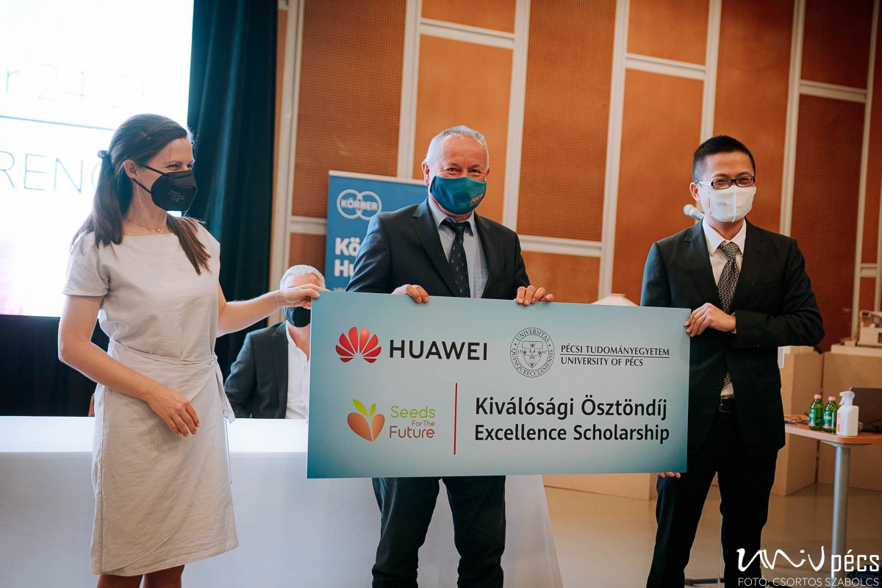
The cooperations cover many aspects of the wide range of activities of the Faculty of Engineering and Information Technology, such as research and development, innovation, regular exchange of knowledge and experience, joint training and education programs, and even the awarding of student excellence scholarships.

In addition to the use of renewable energy sources, company leaders stressed the importance of developing environmentally friendly solutions and technologies and the fact that the industry has never needed so many engineers. Many of them stressed that there is such a dynamic development and renewal in engineering and IT that the skills and innovative attitudes of students and graduates will be in great demand in the coming years.
"It is a very important area of our cooperation to catalyze the relations between industrial enterprises and the Faculty of Engineering and Information Technology and to mediate the needs for higher education knowledge that are emerging from enterprises."

The results of the Körber Innovathon student innovation grant competition were then announced at the Pollack Expo, and the event also hosted the second day of the Simonyi Hackathon competition. The plenary and session presentations provided the opportunity to learn about the latest innovative technological results and research trends, and to discover creative solutions at the trade exhibition. From space construction and 3D printed houses to the merging of info-communications and green energy, the conference brought together a wide range of new solutions, sometimes even hair-raising or sci-fi ideas, covering almost all aspects of life.

