PÉCS MAY BE THE FIRST IN THE COUNTRYSIDE TO LAUNCH A NATIONAL ROBOTIC SURGERY PROGRAM
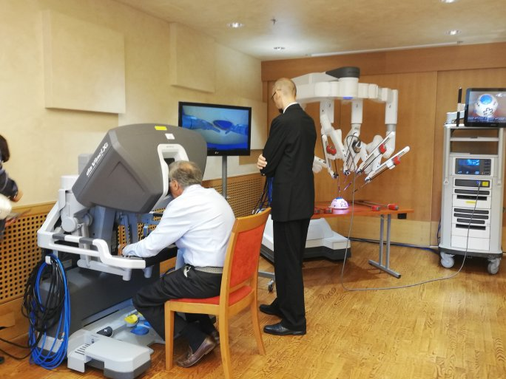
The University of Pécs has recently received the decision from the Prime Minister's Office to support its application for the call RRF-2.1.2-21-2022-00018 "Infrastructure and skills development of practice-oriented higher education". The total value of the project is 3 800 976.744,- HUF, and one of the main elements of the project is the purchase of the DaVinci Xi surgical robot.
The surgical robot is planned to be installed in the Janus Pannonius Clinical Block on Ifjúság street of the Clinical Center of the UP and will perform the most up-to-date robotic surgical procedures in gynecology, surgery, urology, ear, nose, and throat, and cardiac surgery.

This will make Pécs the first university in the country to establish a new base for a national robotic surgery program.

