PATIENT SAFETY HAS FURTHER IMPROVED AT THE CLINICAL CENTER OF THE UP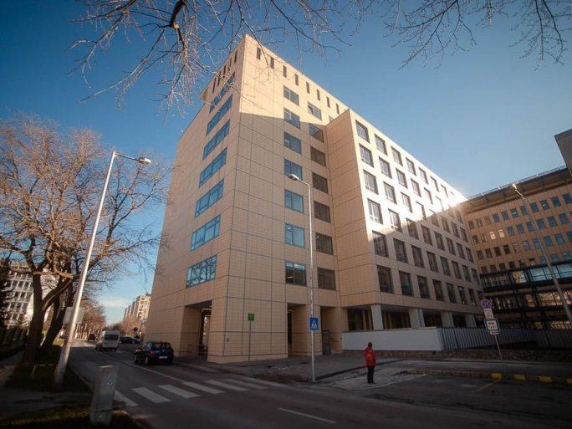
The management of the Clinical Center of the University of Pécs is committed to continuous improvement. In this spirit, during the project "Practical implementation of infection control activities at the Clinical Center of the University of Pécs", which was implemented with the support of the European Union with nearly HUF 60 million, measures were taken that significantly contribute to the prevention of healthcare-associated infections, the quality of patient care, patient satisfaction and patient-, and staff safety.
During the one-and-a-half year project period, which has started in November 2020, under the guidance of Erika Rauth dr., Chief Medical Officer, improvements were made in accordance with the legislation in force, the methodological letters and the professional plan of the project. An internal control system has been developed to monitor compliance with the rules, formulate areas for improvement, and carry out intervention programs.

In order to promote health-conscious behavior among staff, patients and visitors, a hand hygiene campaign was carried out on several occasions, focusing on the correct use of hand disinfection and its control.

This has led to the development of a positive attitude change system where all health workers are aware of the rules to be followed in their work and are committed to applying them in their practice to improve patient safety.

