"PASS IT BACK, BROTHER!" – 2022 SPRING CAMPAIGN

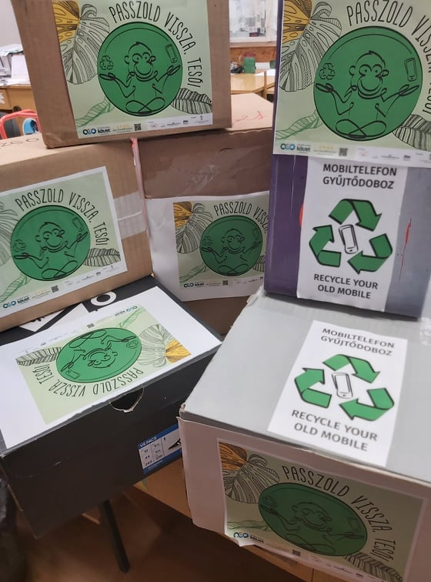

For the fourth year running, the "Pass it Back, Brother!" campaign to collect used mobile phones is being run jointly by the Jane Goodall Institute, the KÖVET Association, the Foundation for Africa, and the Association for the Protection of Children. The University of Pécs joined the initiative 3 years ago. The campaign in the spring of 2022 was organized by the University of Pécs in the framework of the UP Green University Program, with 25 collection points, and participants managed to collect a total of 1169 mobile phones. There were several enthusiastic new registrations, but the picture is also shaded by the fortunate fact that the previous participants of the campaign had done a thorough collecting in previous years, so they were able to collect fewer items but with greater awareness.
"The Green University Program of the UP is a catalyst for green innovations and initiatives aimed at achieving the SDGs. The existence and quality of life of future generations will depend largely on our ability to transform the way we think about the world, our environment, and our lives. Are we willing to change our habits so as not to exploit our natural resources, but to protect our environment, conserve biodiversity and live sustainably? The University of Pécs is at the forefront of this mission in Hungary, and thus, together with its partners, it is constantly initiating awareness-raising actions" - said Tünde Kulcsár, Program Coordinator of the Green University of the UP.

The aim of the campaign is for the partner organizations to
collect as many data-free mobile devices, GPS or tablets, and their chargers as possible,

to promote the circular economy and help save the habitat of Congolese primates and the lives of local communities. Under the principles of the circular economy, the metals extracted from the recovered phones during processing are recycled.

School round
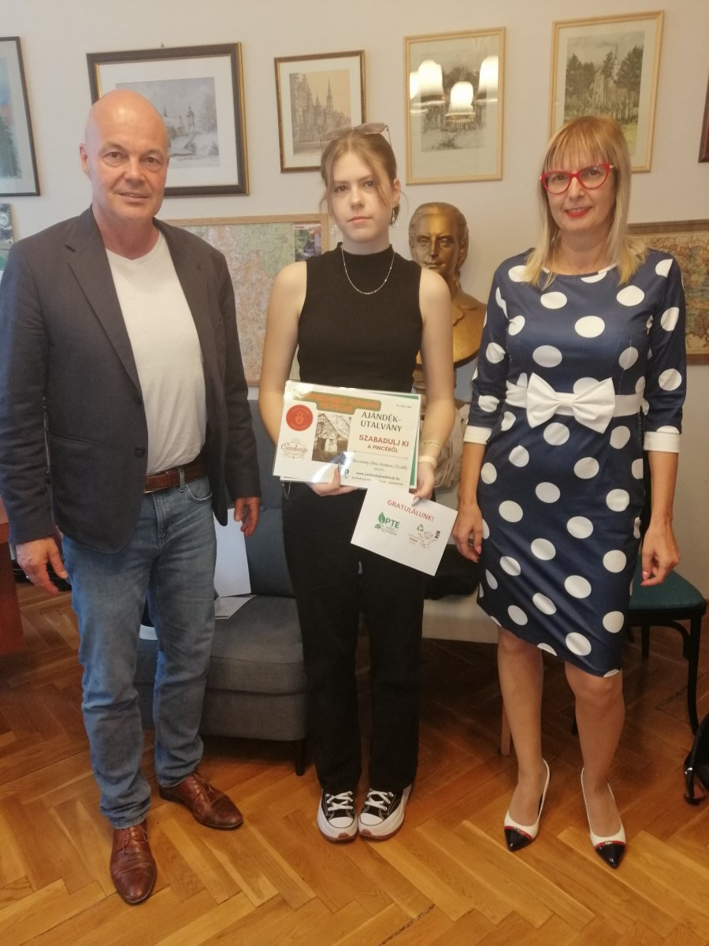
Building on the success of the 2021 campaign, the Green University Program of the UP has again launched a 3-county school round.

The 9th grade class of the Leőwey Klára High School in Pécs already excelled in the autumn campaign in collecting phones, so the "Lakatkaland" outdoor adventure game experience card prize offered by Csámborgó Toy Adventure Tour and the Green University Program of the UP certificate was presented at a ceremony to the most outstanding students of the school.

