NO EXCUSE FOR NOT READING THE GOOD STUFF

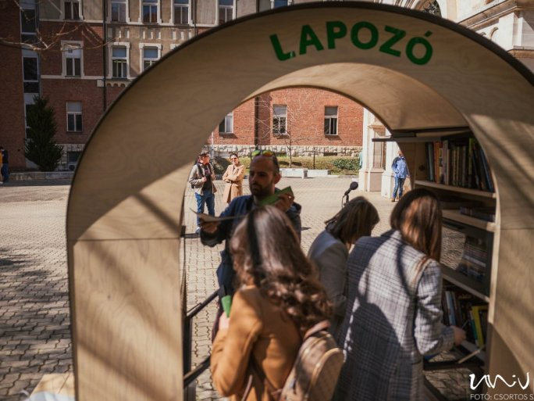
The third book exchange point of Bookline's Turner was inaugurated in Hungary at Pécs, on 22 March, in the joint courtyard of the Faculty of Humanities and Social Sciences and the Faculty of Sciences of the University of Pécs on Ifjúság street.
"Books are valued in Pécs"

- said György Heidl in his welcome speech, and also recalled that a former Ph.D. student had converted telephone booths into a similar book exchange point a few years ago in the framework of competition. So there is almost a tradition of similar initiatives at the university. He stressed the importance of books for humanities scholars and that they could perhaps now be brought back to the fore. The Dean of the Faculty of Humanities and Social Sciences said he hoped that this project would contribute to this process.
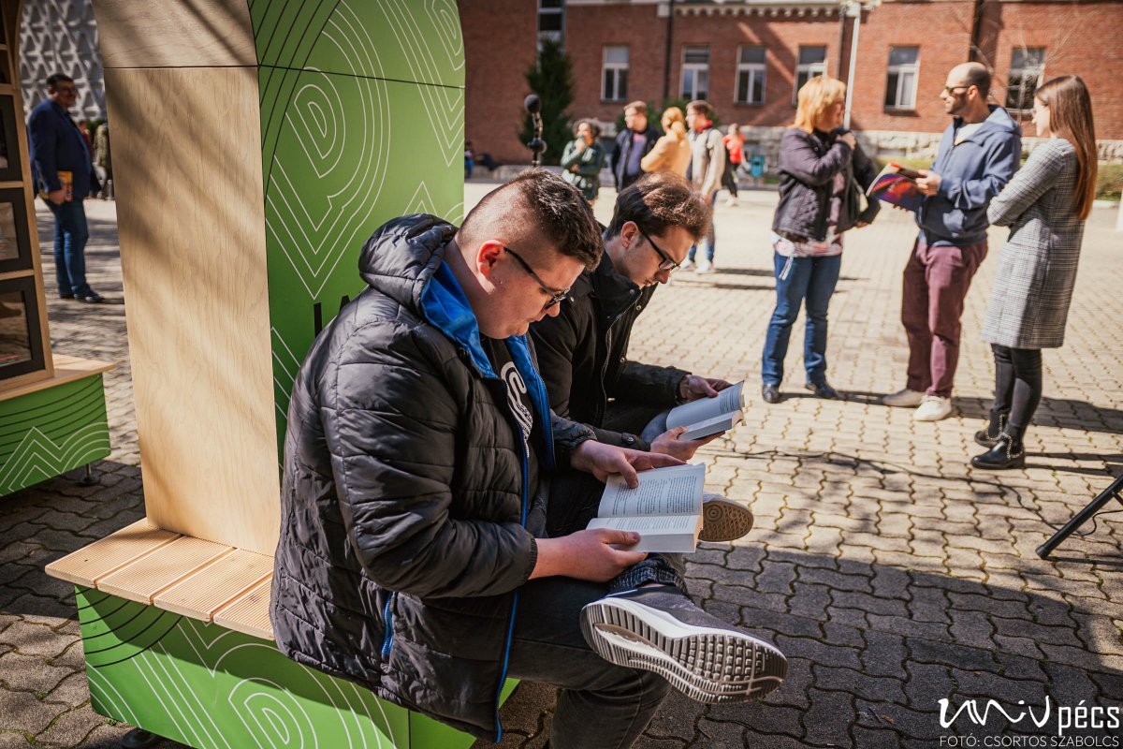
"Twenty minutes of reading a day can build us up! Our aim is to pass on this knowledge".
"It is important that good books are available to everyone."

- and added that he hoped that the establishment of the Turner would also serve this purpose in Pécs.

Zoltán Győrffy, Head of the Relations Directorate of the UP, said that their aim is to create partnerships that not only have a marketing value but also contribute to improving the everyday lives of university students. Such an event last year was the renovation of a former warehouse in the dormitory of Jakabhegy, which was used to create a community space with the partners. Thanks to a donation from Bookline, Turner was set up as a similar project. "It is a great pleasure to have created this book exchange point.
I hope that it will be discovered and used not only by the residents of the University of Pécs but also by other townspeople."

At the opening ceremony, several speakers and staff members of the Dean's Office of the Faculty of Humanities and Social Sciences of the University of Pécs brought books to donate to the book exchange point.

