NEW PROCEDURE TO CURE CORONAVIRUS
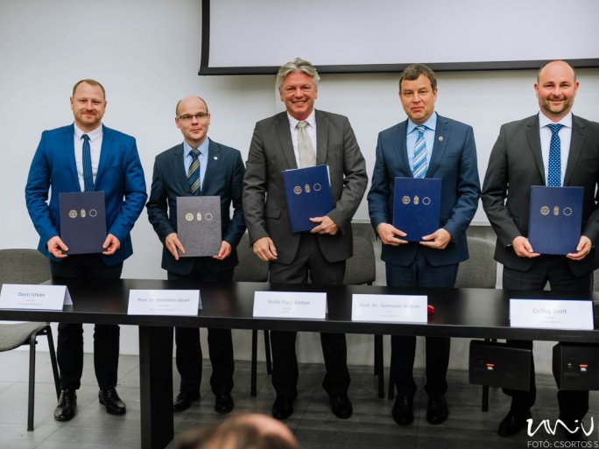
The University of Pécs, CAPTEC Medical Ltd., and the University of Pannonia signs a new research and development agreement. In the framework of the collaboration, the partners will develop a technology platform for the treatment of patients infected with coronavirus, which has already been prepared and is being developed.
Since 2016, CAPTEC Medical Ltd., in collaboration with the Hungarian Academy of Sciences and the University of Pannonia, has been working intensively on the development of a technological platform that can be used to target and remove various pathogens - tumor cells, viruses, bacteria - from the human bloodstream, resulting in an international patent.
In parallel with the emergence of the COVID-19 epidemic caused by the SARS-CoV-2 virus, CAPTEC Medical Ltd. has started to adopt the technology to fight the virus. To accelerate the R&D work, CAPTEC Medical Ltd., in collaboration with the Knowledge and Technology Transfer Center of the University of Pannonia, has signed a cooperation agreement with the University of Pannonia and the University of Pécs to bring the device to the market as quickly as possible to treat patients.
The staff of the University of Pannonia's Research Institute of BioNanotechnology and Technical Chemistry - András Guttman dr. prof., Ferenc Vonderviszt dr. prof., Gábor Járvás dr. - will contribute their experience in protein engineering and biotechnology to the successful implementation of the project. The staff of the National Laboratory of Virology of the University of Pécs, under the guidance of Professor Ferenc Jakab dr., will provide the necessary virological expertise and biosafety background for a successful collaboration.
The collaboration is closely aligned with the efforts of the Ministry of Innovation and Technology to support the active cooperation between fast-growing companies with significant domestic added value and the domestic academic sector.

