NATIONAL MEETING OF INTERNATIONAL COORDINATORS IN PÉCS!
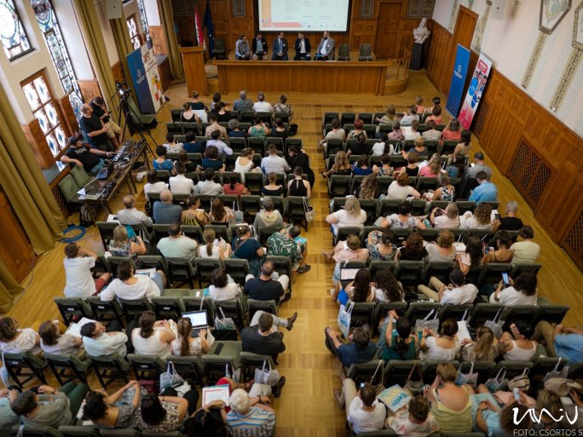
The University of Pécs will host the nineteenth edition of the Tempus Public Foundation's National Meeting of International Coordinators between 29 June and 1 July. The event will feature professional programs, round table discussions, and inspirational lectures, and will be attended by more than 170 international coordinators from 50 higher education institutions from all over the country, with a special focus on Erasmus and CEEPUS. The focus will be on discussing the latest developments and challenges in international programs and presenting good practices.
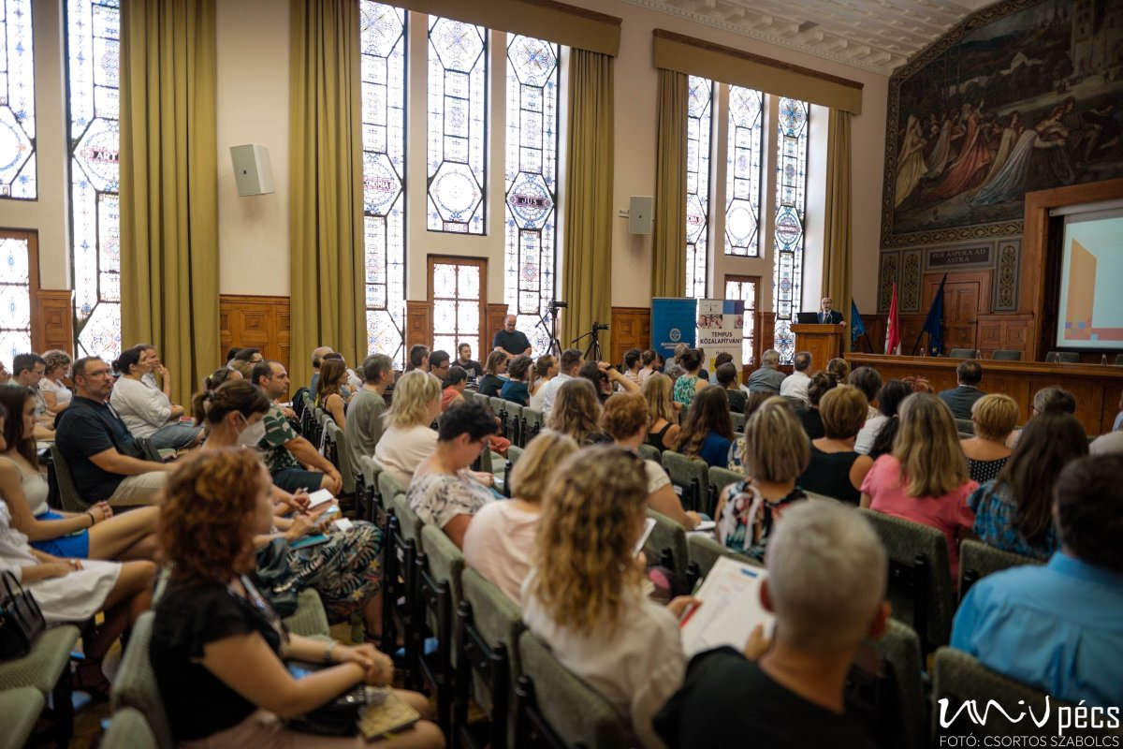

For more than twenty-five years, the Tempus Public Foundation has been coordinating the implementation of scholarship programs that directly or indirectly support the internationalization efforts of Hungarian higher education. These include the thirty-five years old Erasmus+ and CEEPUS programs, which contribute to the competitiveness of Hungarian universities and colleges on the international stage.

In both Erasmus+ and CEEPUS programs, digitalization, inclusion, and green ambitions are high priorities.

