MODERN UNIVERSITY IN THE MODERN CITY
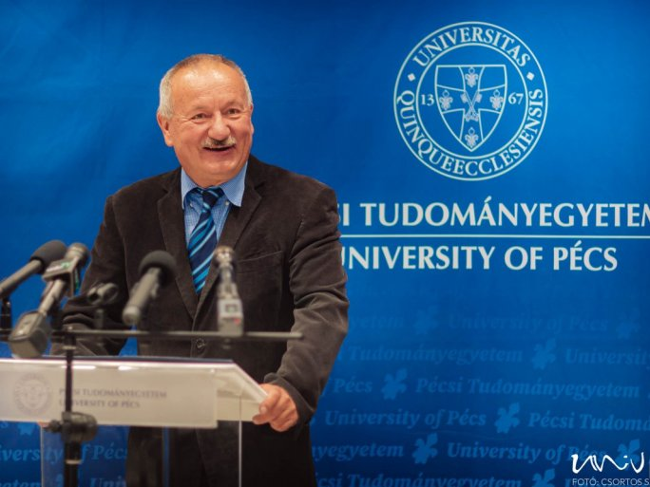
The closing event of the five-year project "A Modern University in a Modern City" was held at the recently inaugurated Dental Center of the UP. The modernization project, which was funded by a 3.5 billion HUF grant from the European Union, involved all the faculties and institutions of the university.
The main objective of the EU-funded program was to reduce the drop-out rate of university students. As a result of the coherent services put in place, students identified as disadvantaged target groups received significant support to stay in higher education and successfully complete their studies, as well as adapt to the changing labor market requirements. In addition, the University of Pécs has expanded, modernized, and digitalized its educational structure in line with economic needs.
The internationalization of the UP is ongoing with institution-level programs and activities. The programs of the faculties of the University of Pécs and the International Directorate coordinating internationalization at the institutional level are and have been carried out in order to enable the University of Pécs, as one of the leading institutions of higher education in Hungary, to become more closely involved in the European Higher Education Area and to further strengthen its international position.
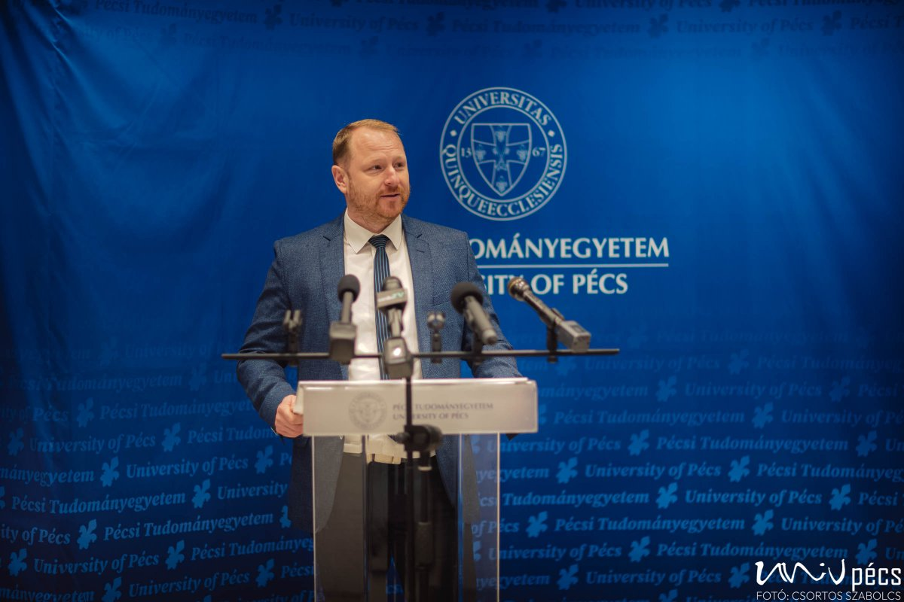
"Our university has a great impact on the economic life of the region and this will be even more evident in the knowledge-based economic development of the region in this decade."
- said István Decsi, Chancellor of the UP in his speech. He stressed:
"More than HUF 500 million has been allocated for IT developments, we have been able to offer scholarships to 800 students from disadvantaged backgrounds and we can also be pleased with partial successes such as the fact that we have managed to increase the proportion of women in the IT faculty to 6 percent."
The aim of the project EFOP-3.4.3-16-2016-00005 "Modern University in a Modern City: value orientation, openness, and inclusiveness in a 21st century higher education model" was to implement a complex institutional development. The project implemented the development plan of the University of Pécs for the period 2017-2021.
The project focused on the coordination of international relations in the Carpathian Basin. The UP provided learning and teaching opportunities and contributed its own knowledge to the implementation of Hungarian higher education courses in the Carpathian Basin region.
Another achievement was the establishment and development of a complex system of sports and health education at the University of Pécs.
In addition, methodological developments, practical skills, and an innovative educational environment have been developed in the field of medical and health sciences training.
Improving access for female students and disadvantaged groups in the fields of mathematics, science, engineering and IT is ongoing and has been a priority throughout the last five years.
At the Faculty of Business and Economics of the UP, a redesign of the economics training portfolio has been implemented with the development of new training programs and a modern toolkit. It is also worth highlighting the significant developments in teacher training in the fields of digitalization, innovation, environmental awareness, and social inclusion.

