LET'S DARE TO PUT OUT THE FIRE!
A fire drill was held on 29 April at the new wing of the Medical School of the UP and on 6 May on the campus of the UP on Ifjúság street, organized by the Department of Work Safety Coordination of the Chancellery of the UP. They also had the chance to try out how to put out a fire in practice.

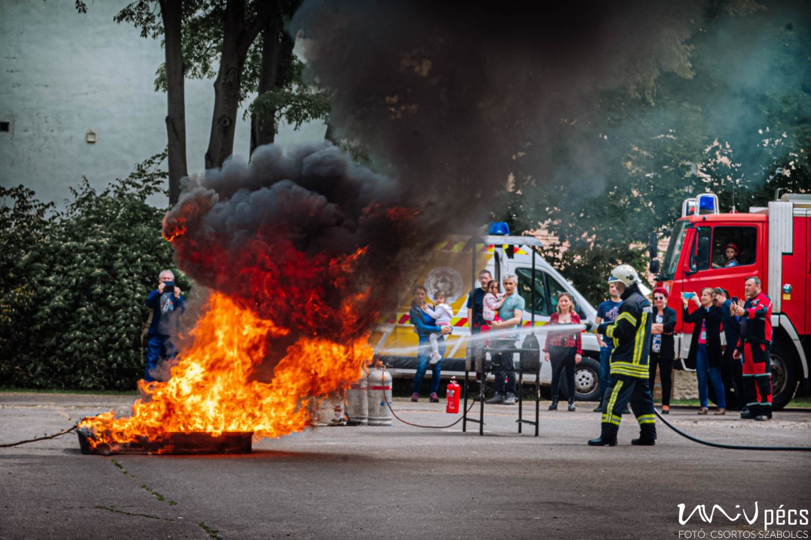

The annual fire drill is a legal requirement and must be carried out at each of the UP's sites at some point during the year. It works well, as the majority of university citizens leaves the facilities in a disciplined manner, using one of the designated safe routes.

The St. Florian Volunteer Firefighters Association provided an opportunity for interested university citizens to try out different firefighting methods under safe conditions.

