INNOVATION PARTNERING DAY
26 MARCH 2022.
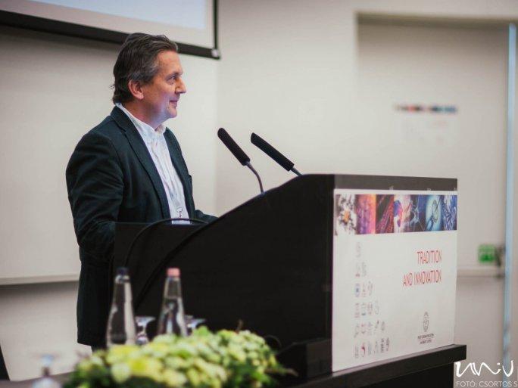
The UP Innovation Partnering Day organized by the Research Utilization and Technology Transfer Department was held on 25 March at the Szentágothai Research Center. The event aimed to strengthen networking in support of the university-based innovation ecosystem, enhance the exchange of experiences between the relevant actors; establish collaborations, create partnerships in the commercialization of priority university developments and innovative results, and showcase student innovative projects that respond to business needs.

"This spring event is mainly about networking, which is one of the most important building blocks of the innovation ecosystem," said Balázs Czibók, Innovation Manager of the Research Utilization and Technology Transfer Department of the UP. "We are building a bridge between researchers, research results, and industry and investors."
The most important part of the Innovation Partnering Day was when the University of Pécs and ten other universities presented their technological innovations, while on the other side eight investors presented the technologies they are looking for and what they can offer to the newly formed spin-off companies. There was also a separate E-poster section where both technology and investor proposals were on display, with 37 technologies and proposals on display for discussion.
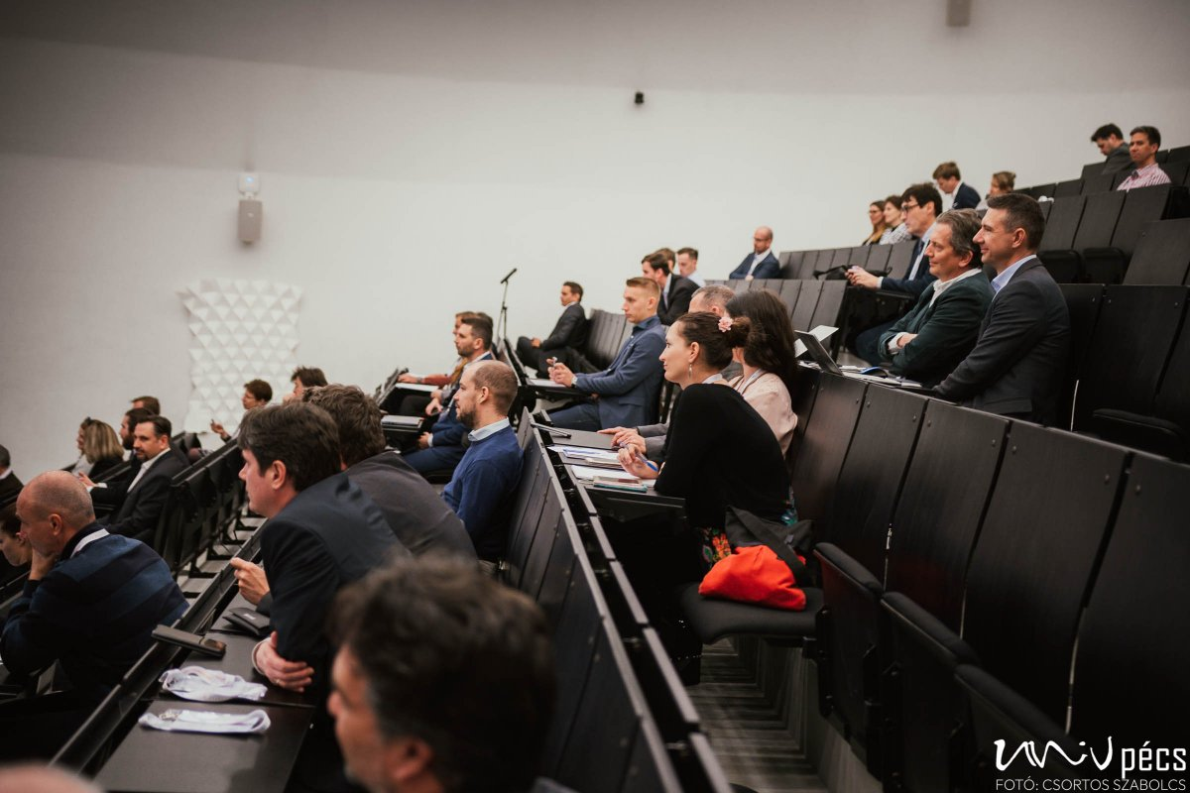
The event was supported by the EFOP-3.6.1-16-2016-00004 project "Comprehensive developments at the University of Pécs for the implementation of smart specialization".

