INNOPÉCS 2022
Within the framework of InnoPécs 2022, the UP Innovation Day was held on 5 May in the lobby of the Faculty of Engineering and Information Technology. The event aimed to strengthen the networking supporting the university-based innovation ecosystem, exchange experiences between the relevant actors, and establish new collaborations. In addition, special attention was paid to the promotion and awarding of university developments, innovative research results, and research projects responding to business needs, as well as to the presentation of student start-up ideas developed in the framework of the Hungarian Startup University Program and the Simonyi BEDC incubation program.
The Innovation Day was followed by the presentation of the UP Innovation Awards, which were open to development projects, ideas, innovations, or innovative research results that contain innovative solutions and insights that respond to existing market needs and thus have business value potential.
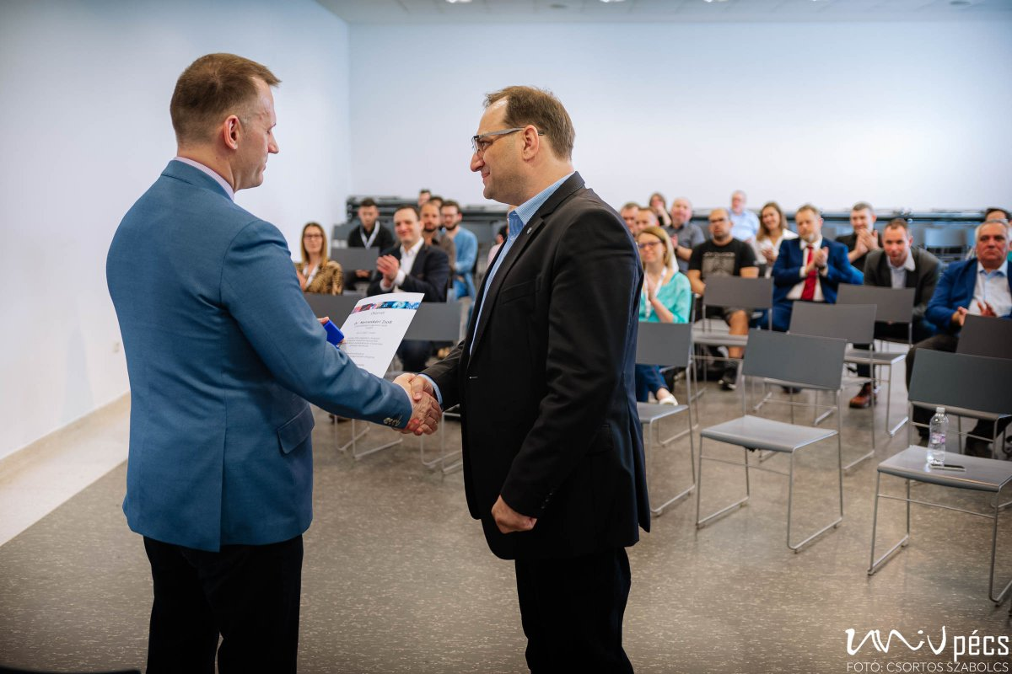
The awards were presented by Tamás Fedeles habil. dr., Vice Rector.
Anikó Kuczkó, the Startup Coordinator of the Input program, said that this is the third edition of their exhibition, which is an innovative exhibition of the city of Pécs, but the event is always hosted by the UP. InnoPécs is about innovative thinking, and they want to show this from as many different angles as possible. The first event focused on the start-up world and the IT sector. This is still the main feature, but this year's program includes many innovative solutions from Pécs, and companies from Pécs and Baranya also showcased their innovations, including traditional companies such as Pécs Brewery, BAT, and Zsolnay. The IT companies were particularly attentive to the students studying in the building of the Faculty of Engineering and Information Technology, and recruitment was among their intentions. This year, the City of Pécs joined the event as co-organizer.
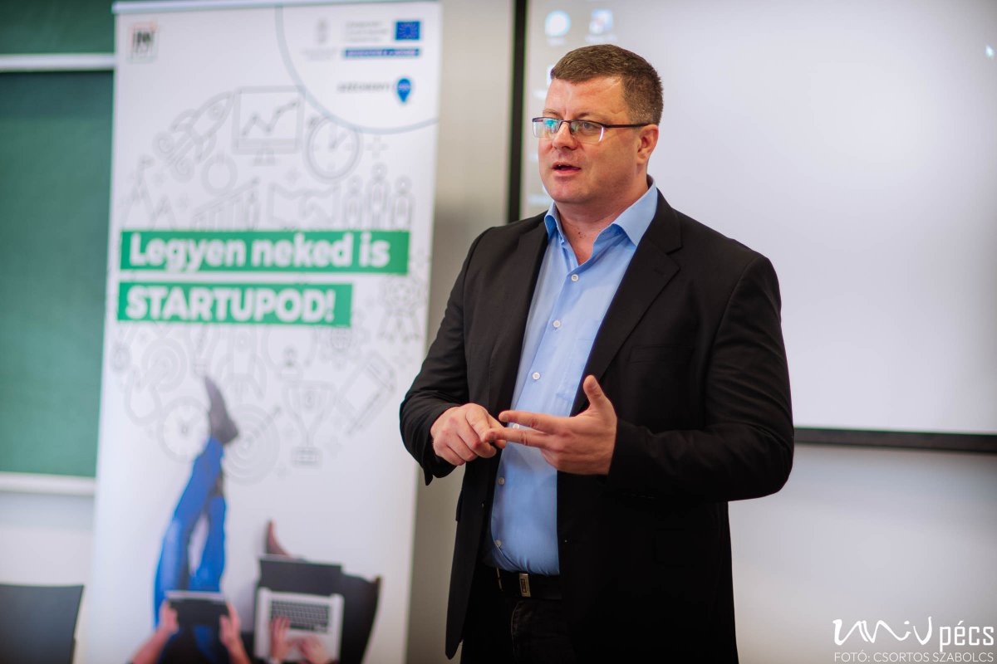
Csaba Ruzsa, Deputy Mayor of Pécs, underlined the role of innovation in the future of Pécs, in which the university plays an important role. The City of Pécs has developed various programs to encourage local economic actors. Pécs has recently joined 100 other European cities in participating in an exceptional EU environmental green grant program (Pécs was selected by the European Commission along with Budapest and Miskolc). This will provide the city with a significant amount of funding to achieve climate neutrality, with the money coming directly from Brussels.

A UP alumni, Samu Csernák, one of the designers of the MusicLabe web application, said that the application is aimed at people who cannot yet play their instruments well enough, but who can use the application to make their musical experience easier.

