INFRARED LASER TECHNOLOGY DEVELOPMENTS AT THE UP IN NATIONAL AND EUROPEAN COOPERATION
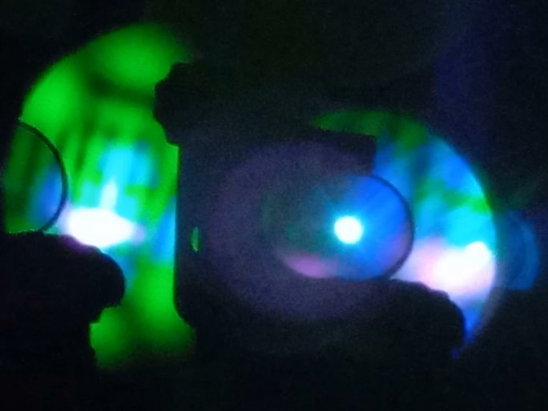
With nearly 80 million HUF in EU funding, researchers from the University of Pécs and its consortium partners are developing a laser workstation that will enable the micromachining of composite materials used in the automotive and aerospace industries. The development work could also bring major advances in the field of laser spectroscopy for security technology. The other Hungarian participant in the project is R&D Ultrafast Lasers Ltd. The European industry-university collaboration also involves German and Austrian industrial companies and researchers from the Vienna University of Technology (TUW).

The international consortium leader in the project is Menlo Systems GmbH,
which was founded by Theodor Hänsch Prof., the winner of the Nobel Prize in Physics in 2005 for his pioneering work in laser physics.

The project ID number is 2018-2.1.5-NEMZ-2018-00003 and the project title is E! 12576 HABRIA national project.

