INFORMATION FOR STUDENTS WHO ARE REFUGEES FROM UKRAINE
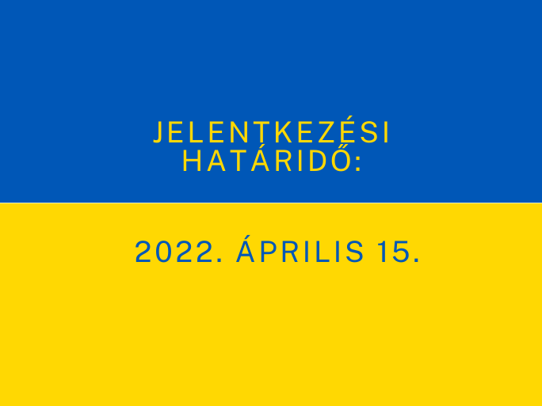
Students who are fleeing from the war in Ukraine but wish to continue their studies in Pécs can apply for the second semester of the academic year 2021/2022 until 15 April at the latest. This was decided unanimously by the Steering Committee of the UP on 7 April.
As is known, students applying for admission or visiting student status at the University of Pécs from Ukraine are automatically exempted from paying the application fee, and the University is currently working on further student-friendly financial details.
The UP has also opened a special application platform for those concerned, with more than 100 English-language courses and hundreds of Hungarian-language courses.
More details on the courses:
https://univpecs.com/egyetemi_elet/pte_fogadja_az_ukrajnabol_menekulo_hallgatokat
The University of Pécs stands for peace and helps those in need.
________________________________________
The UP Help Ukraine menu: https://pte.hu/hu/segitseg-ukrajnanak/hirek

