IN AFRICA - IN THEORY, IN PRACTICE
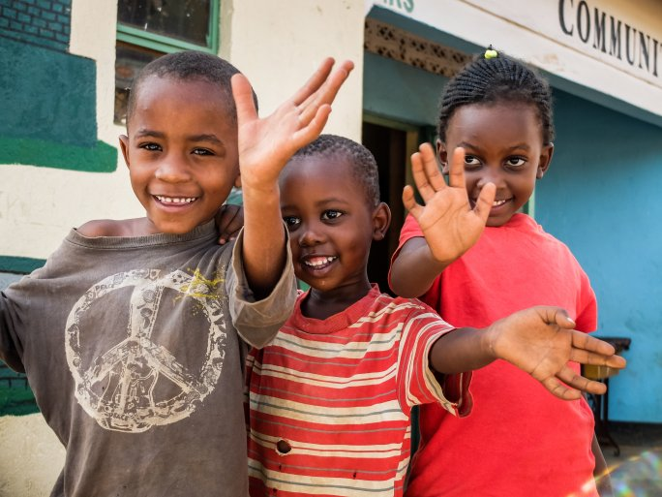
In the framework of the cooperation between the UP and the Hungarian Maltese Charity Service, the fieldwork in Africa has been enhanced with scientific research methods and reflection, so that scientific and educational publications are published based on practice-based research. But what is the basis of the cooperation and what is happening? We spoke to István Tarrósy dr. prof., Head of the International Directorate of the UP and at the same time Head of the Africa Research Center, and Daniel Solymári, Head of International Relations of the Hungarian Maltese Relief Service.

