"Green solutions in Pécs" - presentation of the Green Aura project at the ECOCITY week in Pécs Árkád

Between 2 - 7 May, the field table will be exhibited in the framework of the ECOCITY week, which presents the "green" infrastructure and developments of the University of Pécs and Pécs, using augmented reality. Behind the QR code-like markers placed on the table, virtual content will be displayed using a smartphone application, which will help visitors to navigate through the world of "green" developments in Pécs, while also shaping their attitudes and giving them ideas for sustainable everyday operations. From the thermal power plant to the university and the biogas plant of the waterworks, participants can learn about the sustainability developments that have been launched and completed in Pécs in recent years.
The UP will provide tablets for visitors, but the virtual content can also be viewed on a smartphone.

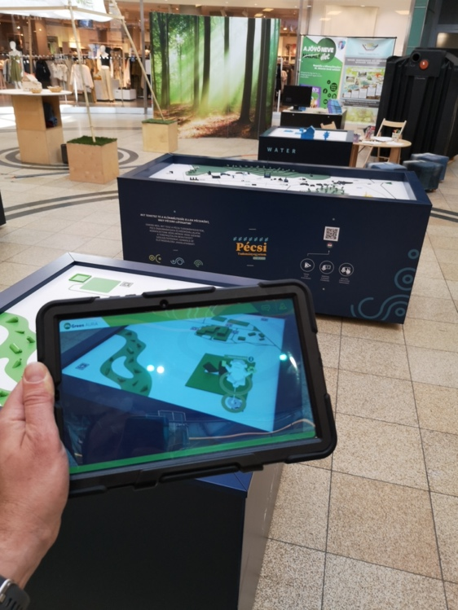
The United Nations estimates that 68% of the world's population will live in cities by 2050, putting enormous pressure on local governments and institutions to ensure a decent standard of living. This is compounded by the need to mitigate climate change drivers and adapt to the climate changes already being felt. These goals can only be achieved by local communities working together and acting together.
The Green AURA project, led by the University of Pécs, is part of the Green University program of the UP. It aims to raise awareness of climate protection developments implemented by two Hungarian and two Croatian partners (the UP, Pécs Urban Development Ltd., Kapronca city, and Northern Energy Agency) through interactive exhibitions using augmented reality, to encourage the public and students to use them and to adopt an environmentally conscious lifestyle.
Building on the experience of the Croatian partners' Living Lab, we aim to make urban developments, university and industrial research, and civic initiatives more widely known and understood, providing opportunities to join the programs. The services, tools, programs, and research available in Pécs will be presented in a mobile exhibition installation, the central element of which will be a table depicting the city. This will be complemented by thematic tables presenting building energy, water, and waste management issues in an accessible way.

The exhibition is part of the Green AURA project (Interreg V - A Hungary - Croatia Cooperation Program).

