**FOR THE SUSTAINABLE DEVELOPMENT**

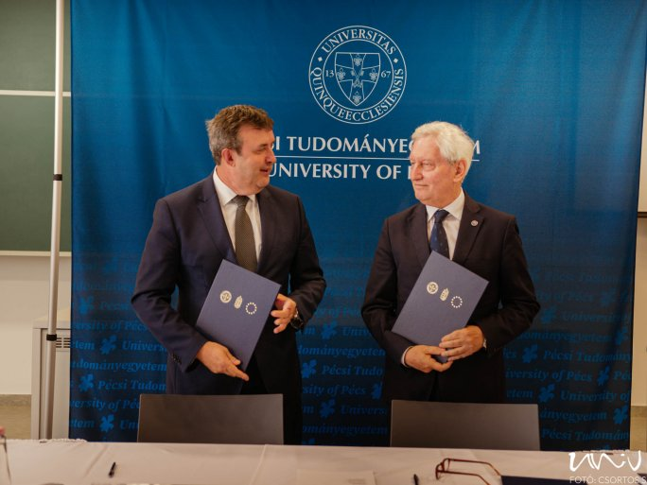

László Palkovics dr., Head of the Ministry of Technology and Industry, and József Bódis dr., President of the Universitas Quinqueecclesiensis Foundation, which operates the UP, signed a cooperation agreement on 17 June at the Faculty of Engineering and Information Technology of the UP.

"Today's event is important, especially in the light of the new system of higher education in Hungary, which goes beyond excellence in education and makes the universities a catalyst for the development of the surrounding economy and region.

This is the role that the University of Pécs has taken on", began József Bódis dr., President of the Universitas Quinqueecclesiensis Foundation, which runs the University of Pécs.

Sustainability is a key element of this decree, which is the basis of the cooperation agreement between the Ministry and UQA.

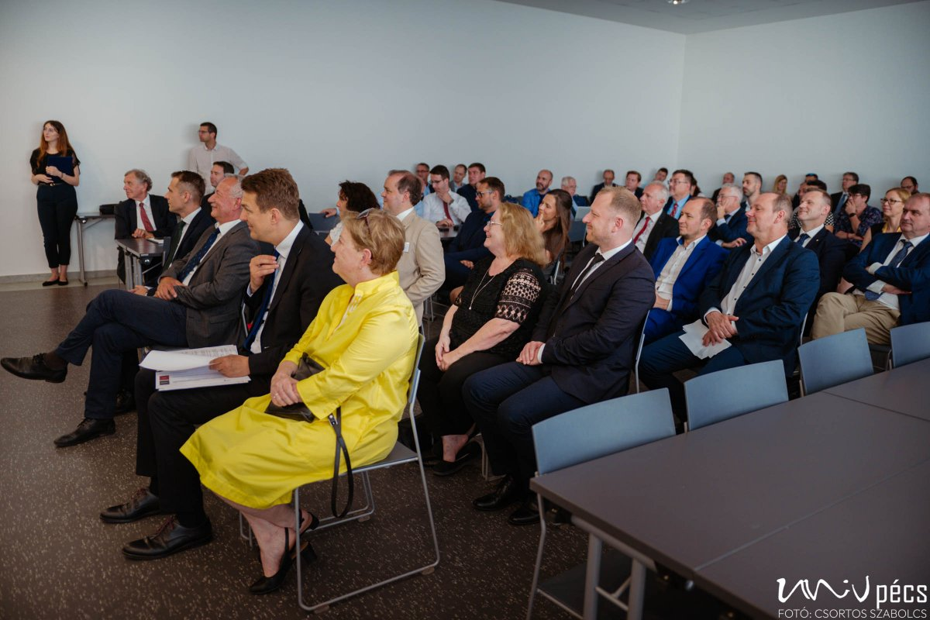

"The first decade of the University of Pécs was about integration. In the second, the emphasis was on internationalization, which changed the atmosphere of the University and of Pécs. Now, sustainability and innovation have also become a focus", stressed József Bódis dr., adding that "today's agreement will define our future."

Energy, transport, industry, and the environment are the backbone of the work of the Ministry of Technology and Industry, László Palkovics said in his expose'.

The Minister stressed that "the University of Pécs has developed in directions that are in line with the objectives of the MTI in recent years, and

According to surveys, the south-western part of Hungary is a good place to set up a large industrial company with its headquarters in Pécs.

The MTI is also a partner in industrial development, and the University of Pécs is the pledge of the knowledge that forms the basis of this development."