FLAVOURS AND AROMAS
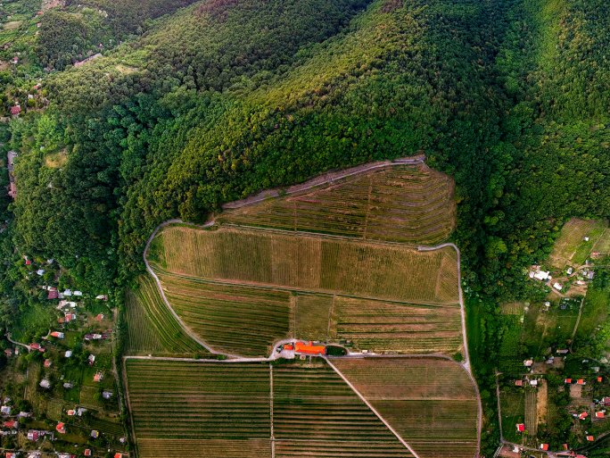
Easter is a celebration of resurrection and renewal, so the Winery of the UP offers its favorite, fresh, and full-of-life wines. The Zenit, Rozé, and Kadarka will enrich the moments of toasting, communal meals, sunbathing on the terrace, and moments of recharging.
The Wine Estate of the UP has the honor to offer its wines in one of the most outstanding, traditional gastronomic citadels of Baranya County - and without exaggeration - in Tenkes Jerry. This cooperation is not only about sales, but also about joint professional thinking.
Gábor Kovács, the owner of Tenkes Jerry, shares his recipes for traditional Easter dishes and recommends them to the wines of the Wine Estate of the UP.

