THE FACULTY OF ENGINEERING AND INFORMATION TECHNOLOGY STRENGTHENED WITH NEW INDUSTRIAL COOPERATION

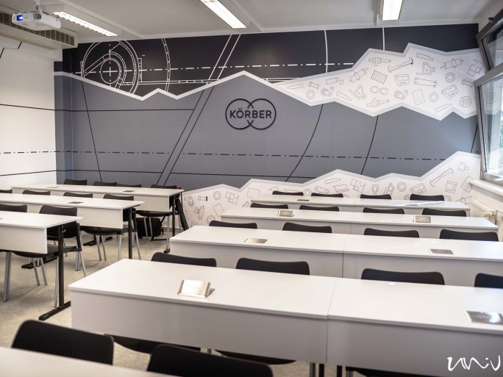
06 SEPTEMBER 2021
Following the opening of the academic year of the Faculty of Engineering and Information Technology of the University of Pécs, the new Körber Room was inaugurated. Its technical system was made suitable for the professionalization of online and hybrid education by Körber Hungary Engine-builder Ltd. of Pécs, which operates an external department at the University of Pécs and is a market leader in the field of tobacco machinery manufacturing.
Joint research and development projects, cooperation in education, and a university training portfolio adapted to the guidelines of the industrial company - these are the areas of cooperation between the Faculty of Engineering and Information Technology of the University of Pécs and two major Hungarian companies: the steel construction, aesthetic and industrial facade cladding design, production and construction company KÉSZ Metaltech Ltd., and Amphenol, one of the world's largest electrical connector system manufacturers with a turnover of USD 8.6 billion last year, founded in Pécs. The University and the representatives of the companies signed the strategic cooperation framework agreement at the opening ceremony held at the Faculty on 6 September 2021.

