METHODOLOGICAL INNOVATIONS AT BABITS HIGH SCHOOL IN THE FRAMEWORK OF ERASMUS PLUS
09 SEPTEMBER 2021
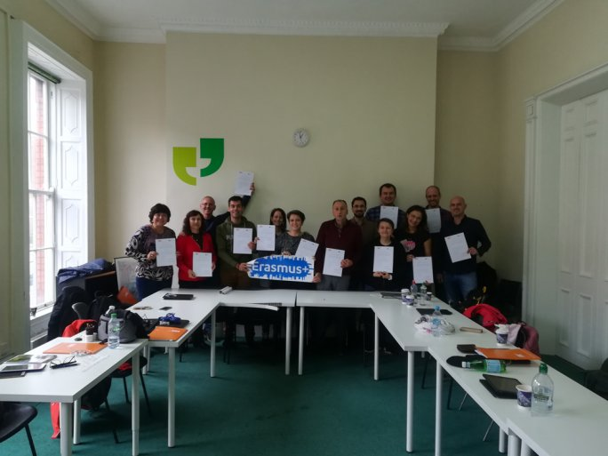
Two years ago, Erasmus+ supported only 99 projects in Hungary. The UP Affiliated Babits High School was one of them with its application entitled "Methodological innovation to increase pedagogical efficiency and effectiveness". The institution has been awarded more than €32,000 for the implementation of international programs to help them achieve their professional development goals:
teacher training and professional visits.
The mobility took place across Europe between 15 June 2019 and 14 September 2021. During this period, 13 staff members of the UP Affiliated Babits Mihály High School, including heads of department, master teachers, head teachers, homeroom teachers, and the school psychologist, travelled to Germany, Italy, Croatia, Ireland, Iceland, Denmark, Portugal, Slovenia, Finland, and the United Kingdom to gain new methodological and practical knowledge and experience.

