MENTOR, TEAM, FAMILY - AND TIME MANAGEMENT
11 MARCH 2021
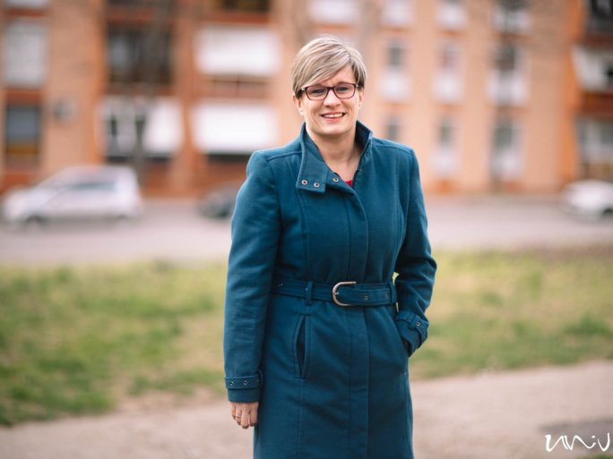
Every year, the Women in Science Association honors young women researchers who have made a mark in both the national and international scientific community and who are keen to promote opportunities for science and engineering careers to young girls. Honouring women researchers in their home countries is a particularly important mission because the proportion of women in science and engineering is still very low.
According to Eurostat data, for example, in 2018, the proportion of women among the 15 million researchers and engineers in the European Union was 41%, while in Hungary it was only around 30%. So girls who are about to embark on a career in science and engineering are in great need of recognized female role models who are high-achievers in their field, active in the domestic scientific community, and at the same time have an excellent work-life balance.
This year, for the first time, the award was also given for the support of research activities, to Klára Stefán Jerkovicsné, a management consultant at the Institute of Geography and Earth Sciences of the Faculty of Sciences of the University of Pécs.
She is a leading figure in the organization and implementation of the Women in Difficult Careers event series and the Women in Science conference and is also a mother of two young children. In addition to all this, she is also an academic herself, as a Ph.D. student at the Doctoral School of Earth Sciences of the UP, studying the modernization impact of German venture capital investments in Central and Eastern European countries.
How much more are girls disadvantaged than boys, how do you see this within the UP?
More girls apply to a university than boys, but this evens out by the time they graduate. The proportion of women in scientific careers varies from discipline to discipline. Among geographers, there are relatively many girls. The teaching profession is also open to both sexes and offers opportunities. My experience is that companies are also increasingly looking to give women a greater role because they have a different perspective.

The Women in Difficult Careers series of events and Women in Science are also linked to your name.
The aim was to show how women in science can be successful. When we were able to meet in person, a core of 30 regulars came to the event, and it depended on the invited guests who else joined us - which is why we dared to go online last May to host our event. This broadened our options: it allowed us to organize a Women in Science conference on such a large scale, with many people coming from across the border. We have built up a circle of nearly 300 people, which is constantly growing and which helps us to move more freely in the online space, and we have developed good professional contacts.

