SCIENCE OF THE FUTURE WILL SOON BE TAUGHT AT THE FACULTY OF ENGINEERING AND INFORMATION TECHNOLOGY OF THE UP
15 JANUARY 2021
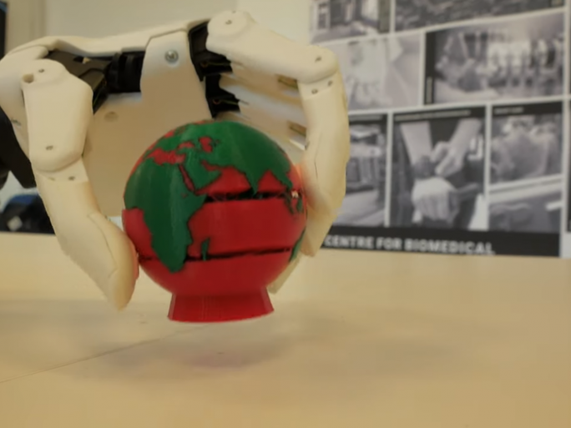
TWITTERFACEBOOKGOOGLE+
The idea that was a sci-fi concept a few years ago has become reality: artificial intelligence teaching prosthetics to work properly, 3D printers producing bone and cartilage replacements, and smart T-shirts measuring people's vital signs to deduce their condition. Long-term research projects bringing together the most innovative engineering and medical disciplines are taking place at the University of Pécs, where several research groups are supported by the "Healthcare software development, healthcare AI, big data" research group at the Faculty of Engineering and Information Technology. Their contribution will open up new opportunities for medical and technical innovation aimed at improving the quality of human life. The intellectual potential generated by these collaborations will be harnessed in the highly anticipated Health Engineering program, which will start next academic year.
The Center for Biomedical Engineering and Innovation (CBEI) was established to run joint developments and innovative solutions between the Medical School and the Faculty of Engineering and Information Technology, providing the background for the work of several research groups. The two main strands of the CBEI are the application of engineering and information technology solutions to medicine and the search for technologies that improve people's quality of life. The research groups also support each other's research, and most of their members are doctors, physicists, therapists, and engineers.
The research team is involved in one of the most promising developments, the pioneering limb prosthesis project Human Arm. The skeleton and covering of the prostheses are 3D printed, so any size and design can be produced. The device can also be taught by an artificial intelligence-based program: instead of the patient having to learn how to adapt his or her muscle function to the prosthesis' fixed settings, the prosthesis can be taught by taking into account the user's behavioral habits. This makes it easier to grasp complex shapes and allows a greater variety of movements.

