Architecture students from the University of Pécs designed the new look of the fairground of Pécs

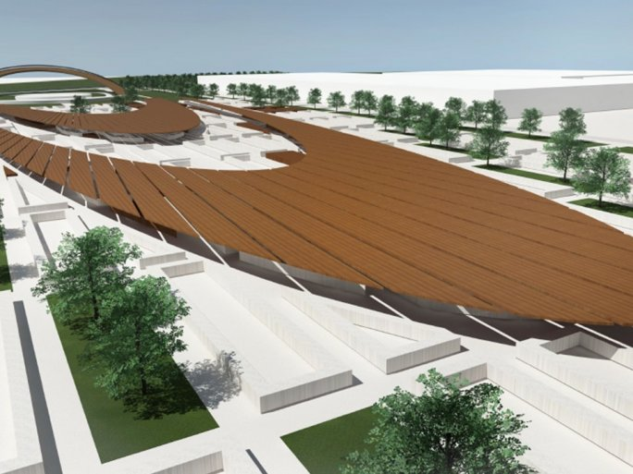

The fairground is an iconic place in Pécs, they say that what you can't buy at the Fair of Pécs, doesn't exist. On a busy day, up to 18-20 thousand people come here, many spending a whole morning browsing the 700 or so vendors. The design and comfort of the area are just as important for visitors as the products on offer, which is why the Asset Management Ltd. of Pécs, the operator of the fair, asked the architecture students of the Faculty of Engineering and Information Technology of the University of Pécs to design a new, unified look for the fairground. The ideas will be presented in a special virtual exhibition between 8 and 31 March, where the public will be invited to give their opinion.

Students from the architecture program of the Faculty of Engineering and Information Technology of the University of Pécs took part in the project, in the framework of two master-level courses.

After learning about the "European Green Capital" program, the students explored the City of Pécs with County Rights, drew up plans for the city's "GREEN" development directions, and then prepared concrete interventions for the fairground of Pécs through action area and environmental design plans.

"As a property developer from Pécs, it is important for us to create modern spaces with a uniform image for the fair, which is both aesthetically and functionally useful. This is why we have concluded a tripartite cooperation agreement with the City of Pécs and the Faculty of Engineering and Information Technology of the University of Pécs."

The finished works will be presented to the public in a virtual public exhibition created by the faculty's teachers and students between 8 and 31 March 2021. The exhibition is available at: https://vr.mik.pte.hu/gallery/7

