NUCLEAR INDUSTRY SPECIALISTS ARE TRAINED FOR THE PAKS II PROGRAM AT THE FACULTY OF ENGINEERING AND INFORMATION TECHNOLOGY OF THE UNIVERSITY OF PÉCS
11 JANUARY 2021.
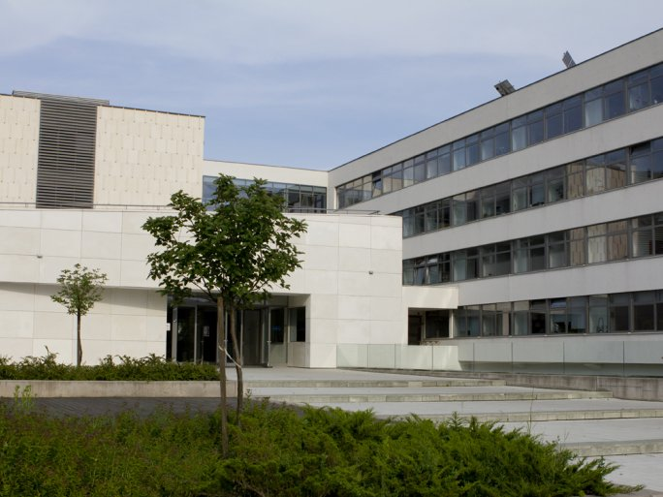

TWITTERFACEBOOKGOOGLE +
There is a growing demand for professionals who want to work in the nuclear industry. Soon, two new nuclear power plant units will be built in Paks to replace the current units, which will be decommissioned. Hundreds of nuclear specialists will be needed to operate the new nuclear power plant. Therefore, in connection with the Paks II program, the Faculty of Engineering and Information Technology of the University of Pécs has launched the courses "Nuclear Power Plant Operation Engineer" and "Nuclear Power Plant Operation Specialist" in February 2020 and is already organizing the next course for February 2021. The graduates will be able to perform tasks related to the operation of nuclear power plant technological processes in the new nuclear power plant under construction, but the knowledge acquired at the faculty can be used in many areas of the nuclear industry.
The specialized further training courses aim to train engineers and specialists who have a basic knowledge of the technological processes of a nuclear power plant (reactor technology, mechanical engineering, water preparation, electrical technology, control engineering, environmental and radiation protection), an understanding of the main technological systems of the plant, the operation process, the basics of nuclear safety and the safe operation of the plant. You can apply for the specialized engineering program by obtaining a bachelor's degree in engineering (e.g. materials, energy, mechanical, mechatronics, chemical, environmental, electrical, computer engineering) or a master's degree (e.g. materials, energy, mechanical, industrial product design, mechatronics, chemical, environmental, electrical, mechanical modeling, computer engineering). Applicants with a bachelor's or master's degree in physics or chemistry are also welcome.
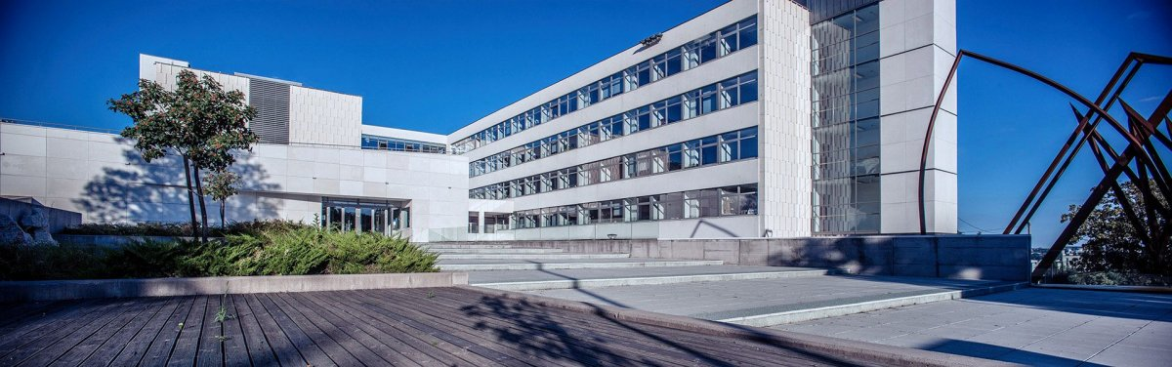
"The training courses, including their objectives, structure, and curricula, are the result of cooperation between Paks II Ltd. and the Budapest University of Technology and Economics, the University of Pécs, the University of Debrecen, the University of Pannonia, the University of Miskolc and the University of Dunaújváros. These partners also work closely together in the field of education," says Anita Kovács dr. Dolgosné, head of the department in charge of organizing the training.

