WOMEN IN SCIENCE 2021
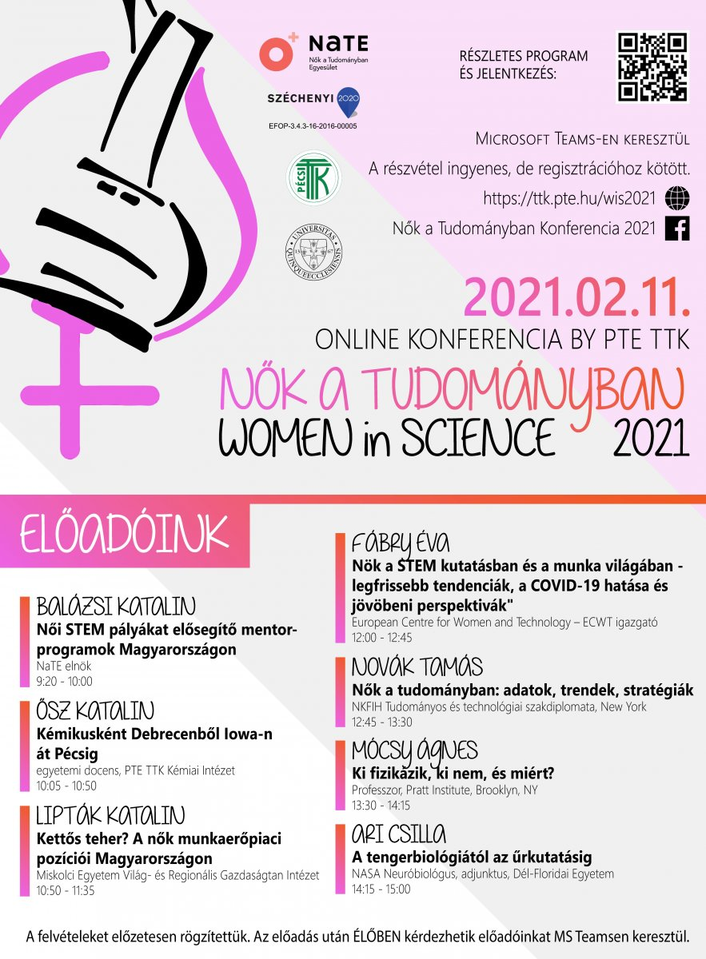
ONLINE international conference

The Faculty of Sciences of the University of Pécs together with the Women in Science Association will organize the "Women in Science 2021" international conference on the occasion of World Women and Girls in Science Day on 11 February 2021, this time in an online format.
The event, which was held for the first time in Pécs in 2020 and attracted more than 300 people, was a great success. Based on the feedback received last year, the organizers will strengthen the international character of the online Women in Science 2021 conference.
Taking advantage of the virtual space, the speakers include a number of internationally renowned women who will share their experiences on the place and status of women in science and who are also truly relevant in the career-work-life triangle. The perspective of the other gender is represented by a leader with significant international experience who highlights the role of women in science.
The conference will focus on STEM (science and technology) fields, the benefits of life as a researcher, and the promotion of science to girls and women. Invited experts will give a 20-minute presentation on their work, followed by a live Q&A session.
Participation is free but registration is required. As the conference may also be of interest in other countries, the Hungarian presentations will be delivered with English subtitles and the English presentations with Hungarian subtitles.
Univ TV's introductory video is available here:
https://www.youtube.com/watch?v=v2WineS7Wjs&feature=youtu.be
Invited speakers:
Katalin Balázsi dr. President of the Women in Science Association
Katalin Ősz, Associate Professor, Institute of Chemistry of the Faculty of Sciences of the University of Pécs
Katalin Lipták dr., Vice Dean, Institute of World and Regional Economics of the University of Miskolc
Éva Fábry dr. Director, European Center for Women and Technology - ECWT Norway
Tamás Novák dr. Specialist Diplomat, NKFIH, New York
Ágnes Mócsy dr. Nuclear Physicist, Professor, Pratt Institute, Brooklyn, New York
Csilla Ari dr. Neurobiologist, Adjunct Professor, NASA, University of South Florida

Location: MS Teams
http://www.ttk.pte.hu/wis2021
Background material
In March 2019, Ildikó Némethné dr. Somogyi and Klára Stefán Jerkovicsné launched the "Women in difficult careers" series of events, in the framework of an EFOP grant awarded by the UP (EFOP-3.4.3-2016-16-00005), where they talk to three women every month about careers in science and engineering. The objectives include presenting careers and career paths that can serve as a perspective for both secondary school girls and university students. The project aims to raise awareness of the diversity of careers in science and technology, their potential and the innovative content of each discipline, and of the many ways in which women can pursue successful and rewarding careers in the family-work-career triangle.
Encouraged by the success of the events, in a changing environment, the series of events has been continued online from spring 2020 (https://www.facebook.com/NokNehezitettPalyan), with a number of new, unconventional, and traditional ventures and events, such as Girls' Day (https://www.facebook.com/events/1642654925882787) and Hire a Researcher (https://www.facebook.com/events/659648841400078).
(1) Nők a Tudományban 2021 – ONLINE nemzetközi konferencia PTE - YouTube

