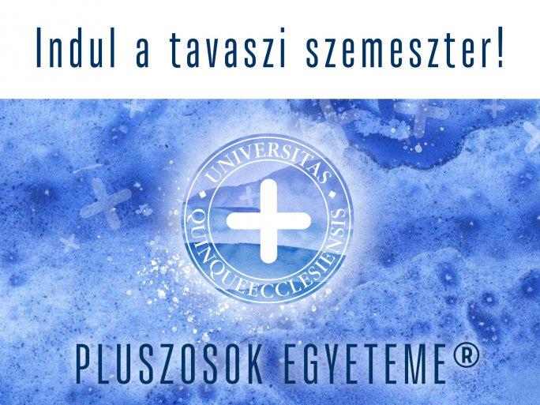
UNIVERSITY OF PLUSES
17 FEBRUARY 2021
Around 350 registered students attended the 8 lectures of the first semester of the University of Pécs' online free university, of which nearly 150 passed the exams and received a certificate of completion for the first semester of the University of Pluses.
At Hungary's first university, the second semester of the Plus program will start on 22 February, with 7 interesting lectures, many of them waiting for those interested in front of the screens with presentations on the issues of aging.
The lectures of the University of Pluses will take place every two weeks on Monday afternoons, starting at 17:00, and are open to the public by pre-registration. The lectures are one hour long and each one deals with a popular topic and is presented by distinguished researchers and lecturers from the University of Pécs. A 45-minute presentation will cover the most important facts, followed by a 15-minute question-and-answer session. Questions can be asked online before and during the lectures.
- The first speaker will be György Udvardy dr., Archbishop of Veszprém and former Bishop of Pécs," said Professor Emeritus Tibor Ertl dr., host of the lectures. - In the continuation, of course, the lecturers of our University will take the stage, medical, historical, astronomical, and many other topics will be discussed, and the semester will be closed by Attila Miseta dr., rector of the UP, who will discuss the future role and opportunities of higher education and our University.

