SHOW THE POSSIBILITIES!
04 FEBRUARY 2021.
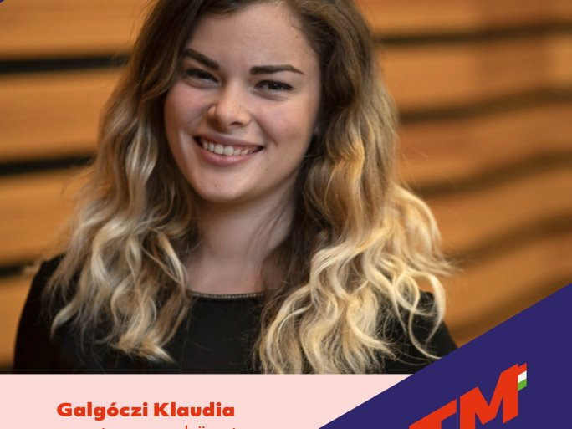
TWITTERFACEBOOKGOOGLE+
Klaudia Galgóczi is a fifth-year student of mathematics, physical education, and teaching at the University of Pécs, and one of the ambassadors of Teach for Hungary! program.
Why did you apply for the program?
I decided to become a teacher when I was in primary school. I like to help others and it feels good when someone understands something they didn't know before, they are grateful for the help. Originally I thought we would tutor during the program, but then it turned out that we didn't quite - if we needed to, we were of course at the child's disposal in that area too. The main aim was to integrate them into secondary and higher education so that they had a vision for the future. The latter is also important because often there is no example in their environment that shows them that it is possible to live differently and what quality of life and world view a higher education can provide.
Once again, the program is recruiting. Why join?
It's perfect for anyone who will be working with people, there is a lot to learn. And as a teacher, especially. You can learn a lot about children and about yourself. It's nice to see them get out of their comfort zone and show them the world, and in doing so give them hope that
they have a chance to make a difference, a chance to have a better life.

